CITY OF HUNTINGTON PARK
Analysis of Impediments
2025-2029

OUTREACH RESULT
Community Engagement Meeting
November 12, 2024

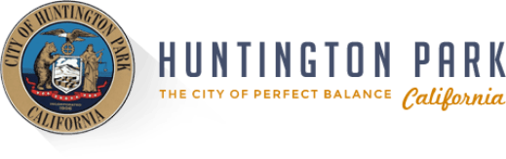
COMMUNITY MEETING OVERVIEW

On Tuesday, November 12, 2024, at 6 PM, residents and community members were invited to attend a public meeting conducted in Spanish at Huntington Park City Hall, located at 6550 Miles Ave, Huntington Park, CA 90255. A total of 13 attendees signed in and actively participated.

The following day, Wednesday, November 13, 2024, at 10 AM, another session was held in English at Freedom Park, located at 3801 E 61st St, Huntington Park, CA 90255. This session was attended by 10 participants who signed in and engaged in the discussions.

The City posted an announcement for the meetings on their social media and sent email invitations to residents who participated in the City’s affordable housing, Home Repair, Emergency Rental Assistance, and social services programs.

Both meetings began with a presentation providing an overview of the 5-year analysis of impediments and the 5-year consolidated plan. Following the presentation, participants were invited to contribute their live feedback by writing their responses on Post-it notes, which they then placed on question boards set up around the room. At the end of each session, attendees were encouraged to complete the community needs survey. The result for this survey will be summarized in the community needs survey section.

THEMES

Through the feedback gathered from the participants, the following themes emerged:

Housing
There is a need to create more affordable housing, help renters become homeowners, and rehabilitate old houses.

Public Services
Participants highlighted the need for services related to Homeless, Fair Housing, After School, and Senior Services. However, they would like to see improved communication about available services.

Community Facilities
Participants highlighted the need for better broadband, repairs to parks and streets, safer crosswalks, and transportation safety.

Economic Development
Participants emphasized supporting small businesses and creating local job opportunities.

LIVE FEEDBACK SESSION

After the presentation, the meeting was opened to receive feedback from participants in four categories: housing, public services, community facilities, and economic development. The questions were asked in English and Spanish. Below is a summary of their responses.

Housing- Do you think the City’s current approach to affordable housing is meeting the community’s needs?

Projects:
- Home Repair Program
- Affordable Housing Projects

Summary:
- 4 participants agree that the current affordable housing approach is meeting the community’s needs
- 1 responded no because many people are unaware of these meeting and have different needs in their lives
- Need to increase housing stocks
- Need to help renters buy homes
- Need to rehabilitate old housing stock
- The Home Repair program is a good program to the much needed

Public Services: Do you believe these programs or services are meeting the community’s needs?

Projects:
- Inner City Visions
- Fair Housing Foundation
- Parks and Recreation After School Program
- Parks and Recreation Senior Program

Summary:
- Nine participants expressed that the current programs and services are meeting the community's needs. One participant suggested that updating Pacific Blvd could help attract better business. Another noted the need for a physical resource center where individuals can learn about and access domestic violence and homeless services, highlighting that Huntington Park struggles with outreach and information dissemination and calling for more creative engagement strategies.
- A participant mentioned that while Inner City Visions serves a small group of individuals (361 people), many more in the community would benefit from the program, and drop-in services are needed on a case-by-case basis. Another participant affirmed that the services offered, such as the program at Salt Lake Park, are meeting the needs of vulnerable individuals.
- There was also a suggestion to expand the Fair Housing Service to include tenant-landlord arbitration. While most participants agreed that the services are meeting their needs, some felt that better communication is necessary to ensure residents are aware of the available services.
- A question was raised about the presence of a homeless shelter in the City, and staff responded that the City partners with an agency that can refer individuals to shelter on a case-by-case basis, though the person must agree to be housed.

Community Facilities: Do you believe any other infrastructure improvements are needed to enhance our community?

Projects:
- Wi-Fi Facility Construction
- Chesley Park ADA improvements
- CDBG ADA Street reconstruction project

Summary:
- Five attendees highlighted additional infrastructure improvements needed to enhance the community. One participant emphasized the need to increase broadband infrastructure, while another mentioned the necessity of repairs to existing parks and streets.
- Several attendees noted that the City has become cleaner, with one individual sharing that their street was being repaved, including parts of California Avenue, with improvements from businesses like Starbucks.
- Participants also pointed out the need for safer crosswalks, with suggestions to repaint lines and improve lighting to ensure cars stop and yield the right of way, addressing pedestrian-vehicle collisions caused by failure to yield.
- A participant was concerned about regulation of the flow of movement in the City, as multiple forms of transportation (pedestrians, runners, bikers, e-scooters, etc.) share the sidewalks and roads. It was stressed that bikes and e-scooters should not be on the sidewalk, which poses safety risk to pedestrians. Protected bike lanes, specifically on busy streets like Florence, Gage, Slauson, and Pacific, to prevent accidents and improve public safety.

Economic Development: Do you believe these economic development programs are meeting the community’s needs?

Projects:
- Hub Cities Job Creation
- Façade Improvement program

Summary:
- 5 attendees expressed that the City's programs are meeting the community's needs. However, several participants emphasized the importance of job creation and supporting small businesses.
- Participants emphasized the need for more diverse businesses to be brought into the City, with a focus on further developing Pacific Blvd to enhance its appeal. They stressed the importance of being selective about the types of businesses introduced, advocating for support of local businesses (e.g., coffee shops) over larger chains like Starbucks. Rather than more large-chain stores like Target or Home Depot, they advocated for revitalizing and supporting local businesses, such as those offering lumber and art supplies, and providing incentives for small business owners over corporations receiving tax cuts.
- It was also noted that incentivizing businesses within the City could help create jobs, as many individuals return to Huntington Park after completing their education but face challenges in finding local employment opportunities.
- Suggestions for improvement included expanding the funding for the Façade Improvement Program and increasing staffing at Hub Cities. There was a call to enhance small business development programs and support the establishment of a regional small business development center.

Other: Do you have other feedback?
Summary:
- One participant expressed appreciation for the meeting and hoped to be invited to future events that are important for the community.
- Another participant provided feedback regarding the management of the Huntington Park Instagram account. They noted that there is significant potential to better engage the community through social media, but currently, the posts are not effectively reaching the audience. The participant stressed the importance of community engagement and requested that the City take social media communication more seriously, as residents rely on it for important information.

EVENT FLYERS

PHOTOS

Tuesday, November 12, 2024, at 6 PM
Huntington Park City Hall, located at 6550 Miles Ave, Huntington Park, CA 90255

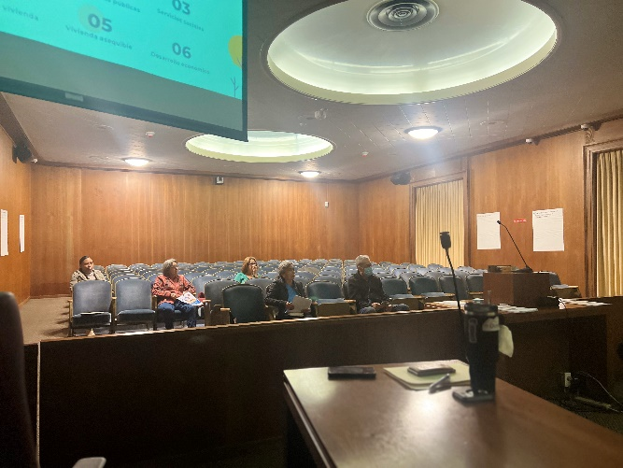

Wednesday, November 13, 2024, at 10 AM
Freedom Park, located at 3801 E 61st St, Huntington Park, CA 90255
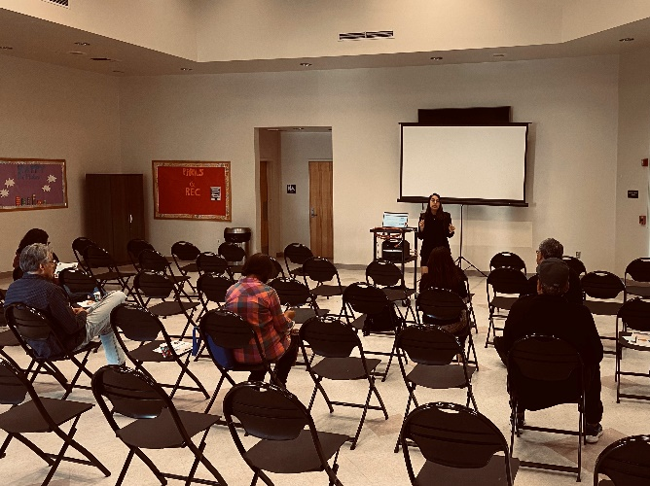
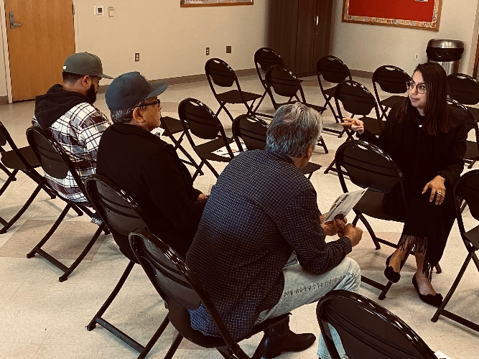
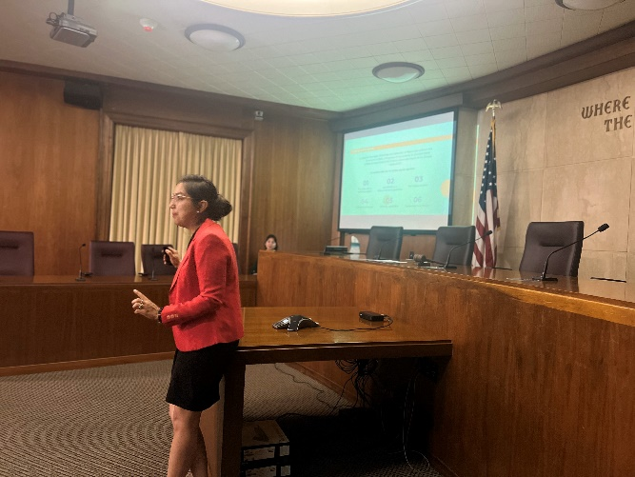
PARTICIPANTS FEEDBACK

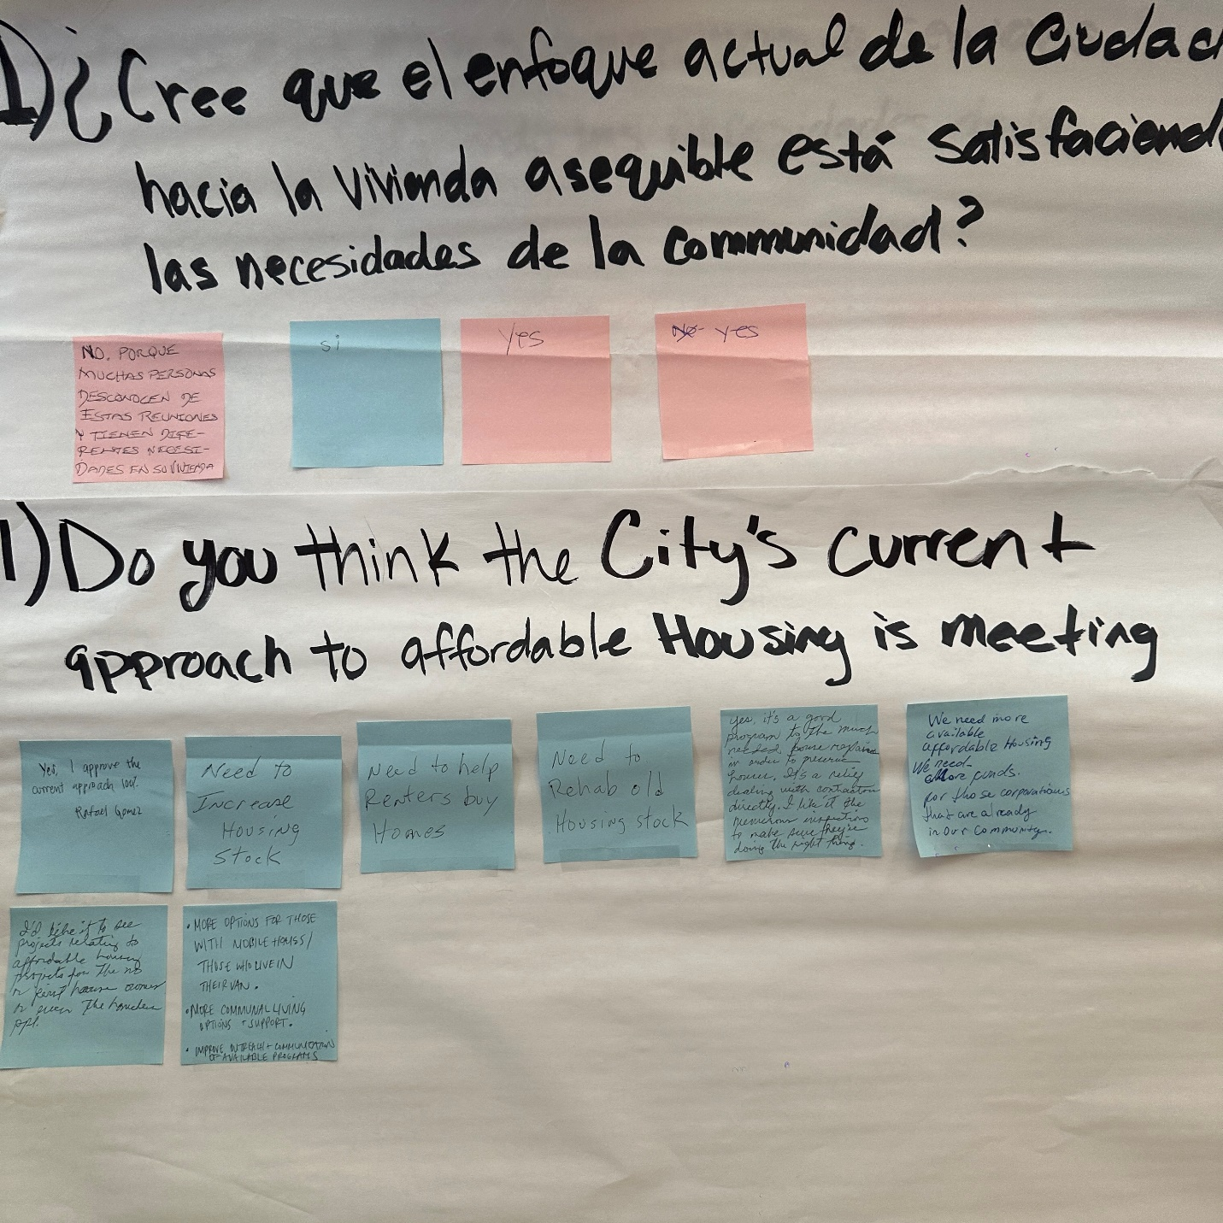

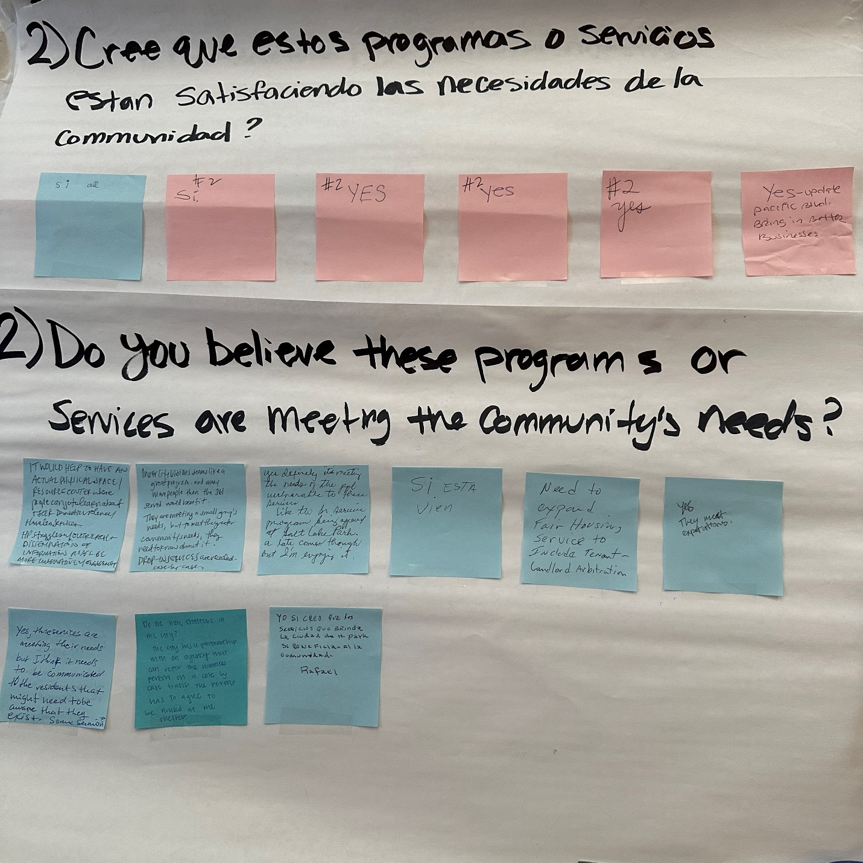

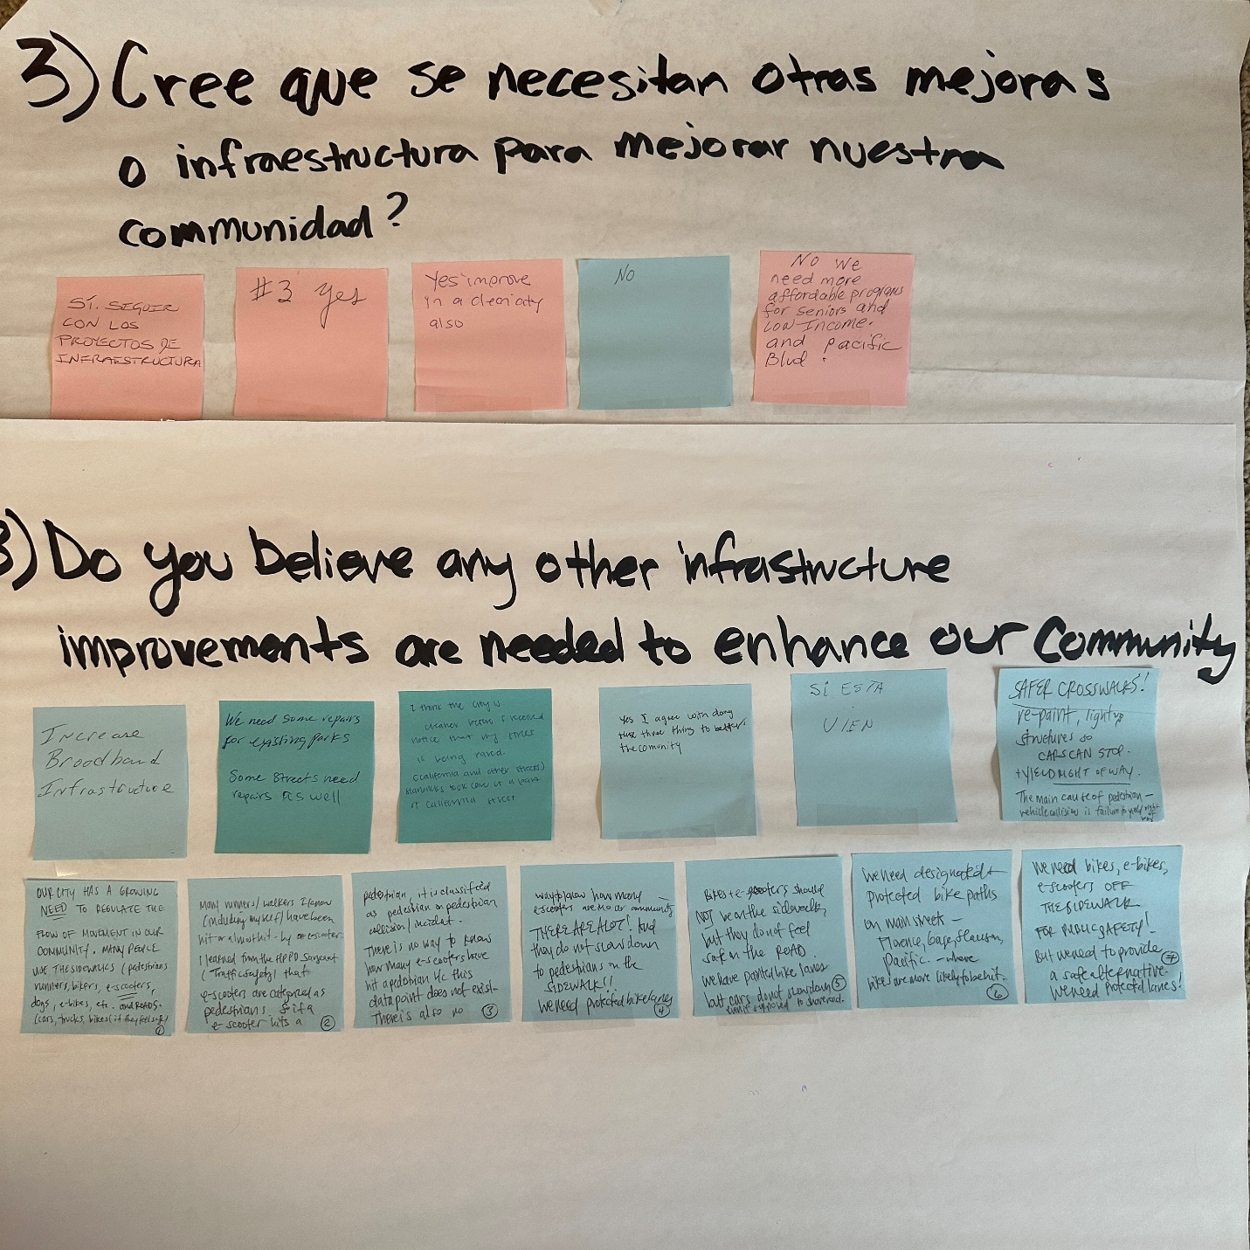

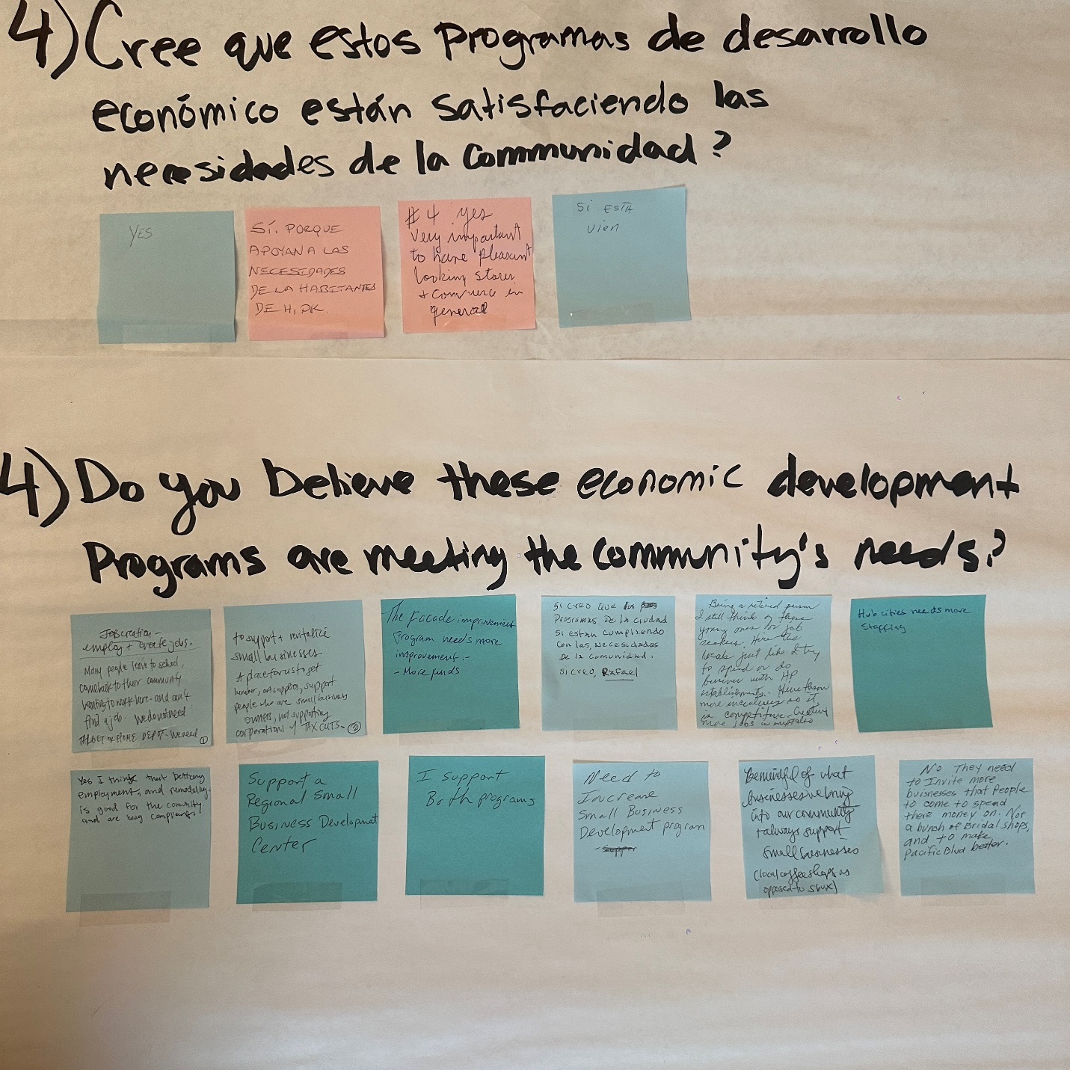

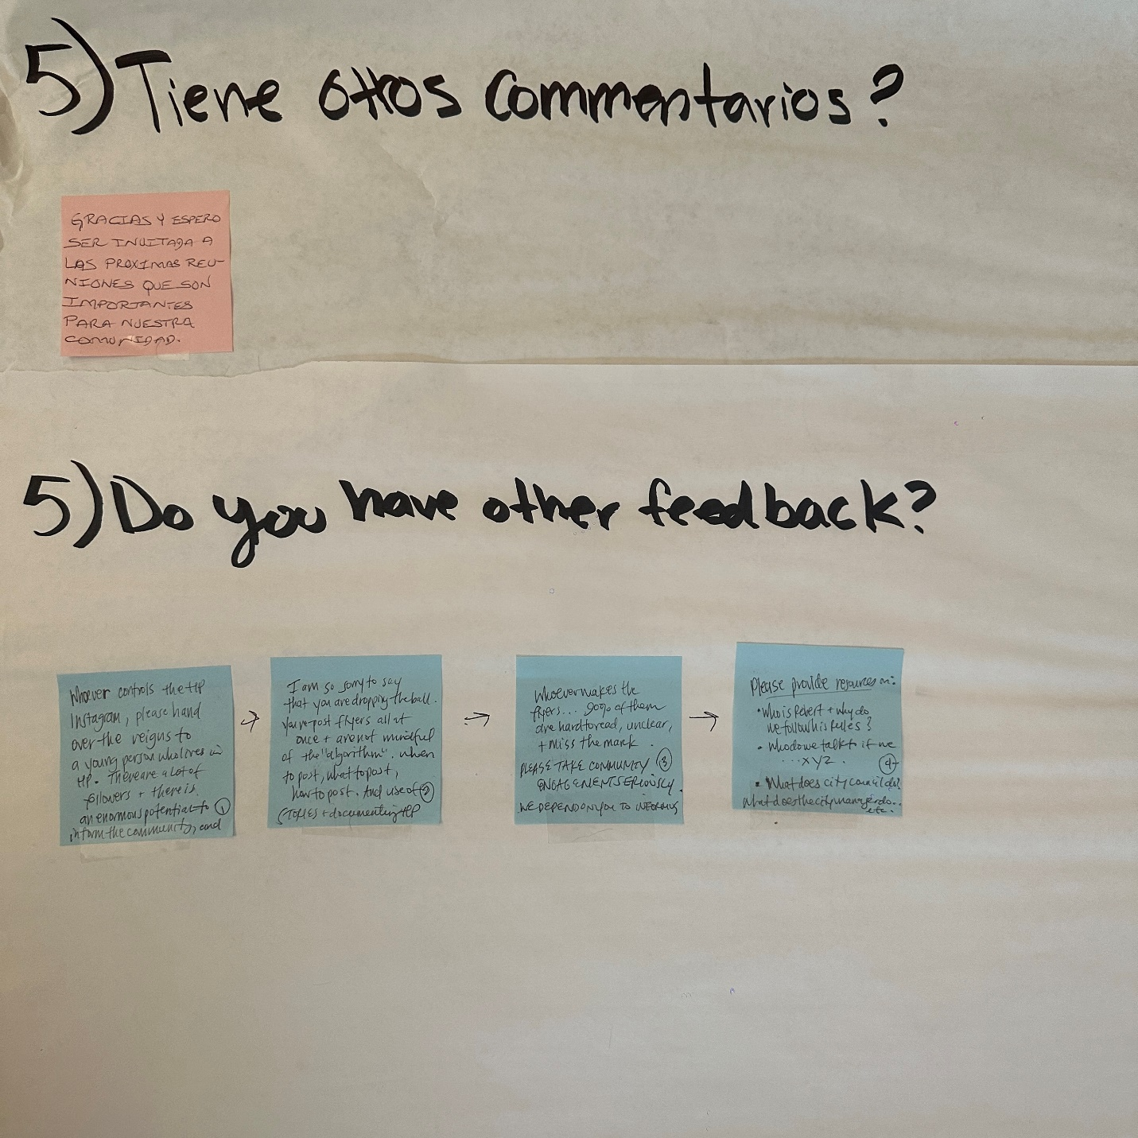

CITY OF HUNTINGTON PARK
Analysis of Impediments
2025-2029

OUTREACH RESULT
Stakeholder Group
September 17, 2024, September 18, 2024, and November 20, 2024
PLANNING COMMISSION OVERVIEW

On Wednesday, September 18, 2024, a presentation discussion for the Con Plan was held before the Planning Commission Meeting to gather feedback on the priority needs of the City. The presentation began by providing an overview of the 5-year analysis of impediments and the 5-year consolidated plan. Following the presentation, participants were invited to contribute their live feedback in four categories: housing, public services, community facilities, and economic development. The feedback provided are summarized below:

THEMES

Housing
Ideas include converting motels into long-term housing, expanding affordable housing, homeownership education, and rezoning for more affordable housing.

Public Services
Ideas include improved outreach about available City programs, supporting afterschool program, and the senior program

Community Facilities
Ideas include ensuring that all parks are America with Disability Act compliant and improving pavements on streets.

Economic Development
Ideas include façade improvement to businesses on Pacific, improving public safety with cameras and better lighting

LIVE FEEDBACK SESSION

Housing: Do you think the City’s current approach to affordable housing is meeting the community’s needs?

Projects:
- Home Repair Program
- Affordable Housing Projects

Feedback:
- John Estrada:
  - Identify a way to establish more affordable housing
- Graciela Ortiz:
  - Amada Project is a good example of what the City needs.
  - Educate children about becoming a homeowner and how to attain that goal
  - Drill down and identify ways to address affordable housing
  - Making more condos, townhomes, and apartments being more readily available for affordable housing.
  - Think outside the box, possibly look at the number of motels the City has and turning those into affordable housing, a more long-term approach project similar to “Project Room Key”.
- Eduardo Carvajai:
  - Rezoning commercial areas for example West of Slauson and making pockets opportunity zones for affordable housing.
  - Slauson St has a lot of opportunities for mixed use development, I would like to see that as a goal.

Public Services: Do you believe these programs or services are meeting the community’s needs?

Projects:
- Inner City Visions
- Fair Housing Foundation
- Parks and Recreation After School Program
- Parks and Recreation Senior Program
Feedback:
- John Estrada:
  - I feel getting the word out to more of the community regarding the programs the City is offering is key. Although the City may advertise, taking a more aggressive approach to communication. My parents and I are residents and we are not aware the City had these programs.
- Graciela Ortiz:
  - Tutoring for children is a more 1 on 1 approach using CDBG funding or other sources and work through Parks & Rec. Many face-to-face activities with children take place at City run programs facilities; utilize that time to foster educating and offering educational activities.
- Eduardo Carvajai:
  - I like the approach of field trips for seniors.

Community Facilities: Do you believe any other infrastructure improvements are needed to enhance our community?

Projects:
- Wi-Fi Facility Construction
- Chesley Park ADA improvements
- CDBG ADA Street reconstruction project

Feedback:
- John Estrada:
  - Community WIFI is a great tool for the community.
  - Ensure all parks are ADA compliant.
- Graciela Ortiz:
  - Only discussion, no specific comment.
- John Estrada:
  - Pavement rehabilitation on specific streets, such as on State St from Randolph to Slauson.
Economic Development: Do you believe these economic development programs are meeting the community’s needs?

Projects:
- Hub Cities Job Creation
- Façade Improvement program

Feedback:
- John Estrada:
  - Only discussion, no specific comment
- Graciela Ortiz:
  - More focus on façade improvements along Pacific as an example
  - Public safety is key, if possible, install cameras on Pacific.
- Eduardo Carajai:
  - More lighting on Pacific would increase safety and business opportunities to business owners to allow stores to remain open longer.
  - Lighting, even stringing lighting across Pacific was once done in past years.
  - Adopt language that speaks to façade improvements, such as, Pasadena. Have a storefront theme, a color scheme, and a canopy type for a more homogenized look among all businesses.

HEALTH AND EDUCATION OVERVIEW

On Tuesday, September 17, 2024, a presentation discussion for the Con Plan was held before the Health and Education Commission Meeting to gather feedback on the priority needs of the City. The presentation began by providing an overview of the 5-year analysis of impediments and the 5-year consolidated plan. Following the presentation, participants were invited to contribute their live feedback in four categories: housing, public services, community facilities, and economic development. The feedback provided are summarized below:

THEMES

Housing
Ideas include increased outreach efforts to help residents’ housing application.

Public Services
Ideas include increased outreach by targeted advertising and collaboration with schools.

Community Facilities
Ideas include improved pedestrian safety.

Economic Development
Ideas include employment support for young adults.

LIVE FEEDBACK SESSION

Housing: Do you think the City’s current approach to affordable housing is meeting the community’s needs?

Projects:
- Home Repair Program
- Affordable Housing Projects

Feedback:
- Liselda Fabian: No response
- Ebony Batiste: No response
- Illiana Baltazar:
  - If we are meeting our goal of 21, we have met our goal.
- Iris Delgado:
  - Have the application and understanding of process more favorable to residents.
  - Have a focus group verses 1 on 1 which will allow residents more likely to apply.

Public Services: Do you believe these programs or services are meeting the community’s needs?

Projects:
- Inner City Visions
- Fair Housing Foundation
- Parks and Recreation After School Program
- Parks and Recreation Senior Program

Feedback:
- Liselda Fabian: No response
- Ebony Batiste: No response
- Illiana Baltazar:
  - Residents having the ability to refer to ICV
  - Advertising to be geared more toward the middle aged who may not be so tech savvy.
  - Schools can communicate City programs during school events.
- Iris Delgado:
  - Looking at bringing in programs not run by the City, ran by other organizations who want to bring additional opportunity

Community Facilities: Do you believe any other infrastructure improvements are needed to enhance our community?

Projects:
- Wi-Fi Facility Construction
- Chesley Park ADA improvements
- CDBG ADA Street reconstruction project

Feedback:
- Liselda Fabian: No response
- Ebony Batiste: No response
- Illiana Tazar: No response
- Iris Delgado:
  - Salt Lake Park is busy, suggested the cross walk at Bissell and Florence be upgraded with a light to allow pedestrians to cross while vehicles stop.

Economic Development: Do you believe these economic development programs are meeting the community’s needs?

Projects:
- Hub Cities Job Creation
- Façade Improvement program

Feedback:
- Liselda Fabian:
  - This should be targeted towards young adults who are unemployed.
  - Summer programs/internships for high school students to gain monies to assist with college.
- Ebony Batiste: No response
- Illiana Tazar: No response
- Iris Delgado: No response

STAKEHOLDER ZOOM FOCUS GROUP OVERVIEW

On Wednesday, November 20, 2024, an online discussion via Zoom was held at 10 AM. A total of 32 people were invited to attend, which included housing, homeless, and social services groups. During the meeting 14 participants attended and represented the following organizations:
- Huntington Plaza Affordable Housing
- Azure Development
- Century 21 Real Estate
- Linc Housing
- Casa Rita Affordable Housing
- New Start Housing
- Pipeline Health
- Huntington Park Parks and Recreation
- Fair Housing Foundation
- Los Angeles County Library
- Inner City Visions
The meeting started with a presentation on the five-year analysis of impediments and the Consolidated Plan. The topic included funding, outreach purpose and strategy, priority goals, and current projects. At the end of the presentation, the attendees were designated their own breakout room based on their organization type: housing, social services, and homelessness. In the breakout room, the participants were asked to provide verbal input for each question and to fill out their thoughts on the Survey link provided. The summary of the feedback received are below:
THEMES

Affordable Housing
The discussion focused on expanding affordable housing through accessory dwelling units, upzoning, and developer collaboration. Key barriers include a complicated entitlement process, lack of funding, and zoning issues. Solutions include streamlining permits, increasing funding, and exploring alternative housing options.

Tenant Support
Offering incentives for apartment owners to make units available to low-income families is essential. Additionally, there is a strong need for enhanced tenant support, including counseling on rent increases, eviction notices, and tenant rights, to help residents navigate housing challenges and protect their living conditions

Vulnerable Populations Needs
Partnerships with non-profit organizations to better address the needs of low-income families, seniors, youths, and persons with disabilities.

Homeless Populations Needs
supporting vulnerable populations with services like mental health care and job training,

Public Facilities and Improvements.
There is a need for more public restrooms, public parking, park ADA upgrades, expanding public Wi-Fi and community centers.

GROUP 1: HOUSING

Question 1: How do you envision the affordable housing landscape evolving over the next 5 years?
- Summary:
  - Azure Development envisions the affordable housing landscape in Huntington Park evolving over the next five years by focusing on incentives to encourage and support residents in building Accessory Dwelling Units (ADUs) for seniors.
  - However, Linc Housing Corporation raised concerns about the challenges in achieving affordable housing growth due to limited funding and subsidies, which make it difficult to develop affordable housing in the City. They recommended exploring private or philanthropic funding as a key solution and suggested expanding ADUs as an alternative housing option. The cost of building affordable homes is not penciled out and even with free land, affordable housing projects are still in the red.
  - New Start Housing Corp suggest that housing units will meet the City’s Housing Element goals. The number of affordable housing units in the next five years will increase by approximately 1600 housing units.
Question 2: In your opinion what are the barriers to building more affordable housing?
- Summary:
  - Azure Development highlighted the timing of the entitlement process as a key barrier to housing development in Huntington Park, suggesting that refining and restructuring this process could encourage more developers to invest in the City. The entitlement process needs to be streamlined, fees reduced, and the permitting process needs to be more efficient.
  - Linc Housing Corporation expressed concerns about the challenges of building affordable housing in Huntington Park, primarily due to the lack of funding and subsidies. They proposed leveraging private or philanthropic funding to address these issues and emphasized the potential of expanding ADUs as an alternative housing solution. Linc also suggested utilizing SB 4 to leverage church land for affordable housing development, advocating for upzoning, streamlining ordinances, and incentivizing affordable housing through these changes. Additionally, they recommended that the City purchase land and issue Requests for Proposals (RFPs) to further promote affordable housing.
  - New Start Housing Corp raised concerns about the difficulties of working with the City under the HOME and CTAC funding programs and noted that the City’s landlocked status limits opportunities for multi-unit housing. They also pointed out that the City’s policies discourage multi-unit developments, which further restricts the potential for affordable housing growth. They advocated for the City to approve the zoning required to build affordable housing on a lot adjacent to the transportation line.

Question 3: What are some of the meaningful actions that can be taken to more adequately address affordable housing?
- Summary:
  - Azure Development emphasized the importance of upzoning and adjusting ordinances to encourage more affordable housing development. They also suggested streamlining the ADU permitting process could lead to immediate improvements.
- Linc Housing Corporation proposed leveraging private or philanthropic funding as a key solution to increasing affordable housing in Huntington Park. They also recommended exploring alternative housing types, such as ADUs, and leveraging SB 4 to utilize church land for affordable housing. Additionally, they advocated for upzoning, streamlining ordinances to incentivize affordable housing, and having the City purchase land and issue Requests for Proposals (RFPs) to further support development. Linc also pointed out that with the transit line coming into the City, Huntington Park has an opportunity to position itself to attract affordable housing and collaborate with developers to secure public funding, such as Affordable Housing and Sustainable Communities (AHSC)
- New Start Housing Corp recommended changing zoning to be more housing-friendly along the transit line and emphasized the need for the City to be more supportive of multi-unit housing projects, especially those with over 50 units.
Question 4: Do you think home ownership is important to area residents/families?
- Summary:
  - Everyone agreed that homeownership is important to area residents. In particular, Azure mentioned that it is important to not lose sight of other incomes and housing needs.
Question 5: What do you feel are the City’s Priority Needs for CDBG and HOME funds over the next 5 years?
- Summary:
  - Everyone agreed that preserving and creating new affordable housing is a high priority goal for the City. More specifically, Azure development suggested unit programming. Participants also believe that there is a need to expand community services.
GROUP 2: PUBLIC SERVICES

Question 1: How do you envision the affordable housing landscape evolving over the next 5 years
- Summary:
  - New Start, Fair Housing Foundation, Parks and Recreation emphasized the need for more funding to expand programs and build affordable housing to reduce being wait listed.
  - The Fair Housing Foundation faces a significant challenge in securing funding, despite the growing need for its services in the City of HP. Their focus is to increase its presence in the community to ensure that residents are informed about where to seek help and how to protect their housing rights. An example is the Salt Lake Park Fair Housing Workshop. Residents need to know who to call for resources to preserve their housing.
  - Inner City Vision stated that there is a lack of permanent housing

Question 2: Do you know of any community facilities or public improvements needed in the City? (parks, streets, flood prone areas, ADA improvements, facilities for youth/senior)
- Summary:
  - The Parks and Recreation Department expressed how fortunate the City is for the improvement of Chesley Park, which will make it the first park with ADA accessibility. However, there should also be a focus to update the park's playground to meet ADA standards. There is a need for more public restrooms, particularly at Salt Lake Park, and along Pacific Avenue from Florence to Slauson on Pacific, there are currently no restrooms available for shoppers. The community would benefit by creating pocket parks with restrooms, as businesses charge for restroom access, and there is a broader need for public restrooms.
  - Fair Housing expressed their gratitude for Parks and Recreation to allow fair housing events to be hosted at Salt Lake Park. They would like to see more access to updated community centers.
  - NewStart Housing stated the need for funds to provide space for other non-profit partners to provide services to the community. Salt Lake Park needs some upgrades in the open space/ground and the tennis fields.

Question 3: What meaningful actions can be taken to more adequately address affordable housing?
- Summary:
  - Parks and Recreation suggested having information readily available to share with individuals on where to find affordable housing.
  - Inner City Visions emphasize on policies that would include incentives for apartment owners to utilize apartment units for low-income populations
  - Fair Housing stated that affordability remains a major issue statewide, with access to affordable housing being a top priority. Ensuring families are housed, rather than becoming homeless, is crucial. Rent stabilization is of particular interest, as many face challenges in securing affordable housing due to long waiting lists. It is essential for individuals to get on these lists early. Additionally, clients can be referred to available affordable housing units, though the demand continues to outpace supply.

Question 4: How can we ensure that the needs of the City’s most vulnerable populations are adequately met (LMI families, seniors, homeless, persons w/disabilities)
- Summary: Azure Development
  - New Start suggested thorough assessments done in different sectors of the City, and to partner with nonprofit and for-profit corporation

Question 5: Do you feel there is an issue with internet access?
- Summary:
  - New Start believes that the City needs better service, lower cost internet providers in the area, and for AT&T to continue expanding their fiber optic throughout the City.
  - Parks and Recreation stated that it’s important to announce the WIFI access program for its residents. There is a need to distribute flyers to spread the word and provide password information to the community. Marketing materials are essential to ensure residents are aware of this resource. Additionally, Spectrum charges low-income clients more than those in affluent areas like Beverly Hills, highlighting a need for affordable internet options. To address this, a technology class could be offered at the senior center, and efforts should be made to connect with local schools to further support digital inclusion.

Question 6: What do you feel are the City’s Priority Needs for CDBG and HOME funds over the next 5 years?
- Summary:
  - New Start thinks Affordable Housing and creating public parking spaces to take advantage of the empty lots around the City are top priorities.
  - Parks and Recreation thinks homelessness, gang prevention, and affordable housing are the top priority needs. There are many families who live in their car every day.
  - Fair Housing Foundation believes in expanding the Fair Housing Services. The organization faces significant challenges in providing counseling on critical housing issues, such as understanding rent increases, eviction notices, and their implications. They also assist residents in navigating how to request necessary repairs related to habitability and explore tenants' rights to reasonable accommodations and modifications. The foundation helps with investigating housing complaints and advising on how to engage Code Enforcement and the Health Department for repair requests. Additionally, they offer guidance on tenant rights and responsibilities, including access to Legal Aid for issues like unlawful detainers and small claims. The foundation plays a vital role in ensuring tenants understand their protections and have the support needed to address housing challenges.
GROUP 3: HOMELESSNESS

Question 1: In your opinion what are the challenges you face providing services over the next 5 years?
- Summary:
  - Inner City Vision stated that the primary challenge to providing services is the lack of funding and the lack of permanent housing. There is a critical need for additional funding to expand programs, build more affordable housing, and allow for more hours of service. There is a need to scale services on a 5-year plan with clear paths for prevention, intervention, and outreach to keep people from becoming homeless. Many homeless people struggle with substance abuse, and some are undocumented making it difficult to find housing placement in the current system. There will be an increase in demand for services, the goal is to end homelessness in 5 years, but it’s difficult due to economic and political pressure.

Question 2: Do you know of any community facilities or public improvements needed in the City? (parks, streets, flood prone areas, ADA improvements, facilities for youth/senior)
- Summary:
  - Inner City Vision stated there is a strong need to improve lighting in specific areas around the park zones, as well as along well-trafficked streets on the outer edges of the City, including the border streets of Vernon, Los Angeles, Maywood, and South Gate. Upgraded lighting would enhance safety and accessibility. Salt Lake Park, the City's largest park, would greatly benefit from renovated restrooms and much-needed lighting improvements. Additionally, a trauma prevention initiative is essential to support at-risk children in the community who are unable to afford sports and recreational activities, providing them with positive alternatives and support. More specifically, there is a need for a activity facility for at risk youth since there is no trauma prevention at school to prevent children from joining gangs.

Question 3: In your opinion what are the barriers that exist to finding permanent affordable housing?
- Summary:
  - Inner City Vision stated barriers to finding permanent affordable housing include an insufficient supply of affordable units, exacerbated by a lack of subsidies, incentives, and zoning changes that restrict development. Local zoning laws and complicated permitting processes further delay the creation of affordable housing, while high construction costs and limited financial incentives make it difficult for developers to build. Financial barriers such as poor credit or prior eviction records also prevent many individuals from accessing available housing. Anti-discrimination law needs to be enforced to end discrimination based on race, gender, or disability and educate landlords. Additionally, there is a lack of targeted housing options for specific groups, such as women with children, individuals with substance abuse issues, and pet owners, leaving them especially vulnerable.

Question 4: What are some of the meaningful actions that can be taken to more adequately address homelessness in the City?
- Summary:
  - Meaningful actions to address homelessness in the City can include creating policies that prioritize affordable housing development and provide support for vulnerable populations. This could involve working with landlords and housing management to establish agreements that reserve a portion of rental units for individuals experiencing homelessness or at risk of homelessness. Policies should focus on providing housing with supportive services, such as mental health care, substance abuse treatment, and job training. Additionally, creating incentives for landlords to accept tenants with barriers like poor credit or prior evictions, alongside tenant protection laws to prevent discrimination, would help ensure housing stability. Streamlining the permitting process for affordable housing and offering financial assistance to both tenants and developers can further aid in addressing homelessness effectively.

Question 5: How can we ensure that the needs of the City’s most vulnerable populations are adequately met (LMI families, seniors, homeless, persons w/disabilities)
- Summary:
  - Conducting comprehensive community assessments will help identify specific needs, while partnering with community-based organizations can provide direct insights and feedback from those most affected. Improving accessibility and infrastructure, particularly in housing and public services, is essential for ensuring these populations have equitable access. Strengthening community engagement by involving vulnerable groups in decision-making processes will help ensure their voices are heard. Expanding homelessness prevention programs and providing subsidiary housing options for the most vulnerable families can reduce displacement and prevent homelessness. Additionally, connecting seniors and undocumented families to existing resources and services will ensure they can access the support they need to thrive.

Question 6: Do you feel there is an issue with internet access?
- Summary:
  - There are still some spaces and families that need access to the internet. However, the Parks does have public access to WIFI. The rest of the City will follow soon, and families will no longer have to struggle and pay $50-$90 for Wi-Fi at home.

Question 7: What are the City’s Priority Needs for CDBG and HOME funds over the next 5 years?
- Summary:
  - First, affordable housing preservation and development must be a top priority, with a particular emphasis on creating low-income housing for families, not just individuals. This includes repurposing single-family homes into multi-family housing, like initiatives across other Los Angeles cities. Additionally, homelessness prevention and support services will need continued funding to help address and reduce homelessness in the community. Youth and senior services should also be prioritized, ensuring that development and accessibility meet the needs of these groups. Ultimately, the City should focus on affordable housing and enhancing services to support vulnerable populations across the community.

CITY OF HUNTINGTON PARK
Analysis of Impediments
2025-2029

OUTREACH RESULT
Community Needs Survey
October 15, 2024, to November 15, 2024

COMMUNITY NEEDS SURVEY
The City of Huntington Park conducted a community survey from October 15, 2024, to November 15, 2024, to gather input for the City’s 2024-2029 Consolidated Plan. A total of 291 residents participated, with 237 responding in English and 54 in Spanish. The survey included 23 questions aimed at gauging public opinion on priority goals for the upcoming planning cycle. Topics covered in the survey ranged from housing and community facilities to homeless housing, neighborhood improvements, community service needs, broadband access, and disaster preparedness. The result of this survey provides valuable insights into the needs and priorities of the community.
THEMES

Affordable Housing
- Owner occupied housing rehabilitation
- Increased Senior housing units
- Construction of new affordable rental housing
- Low barrier to affordable housing development
- Affordable rent

Public Services
- Neighborhood crime prevention: Safety: Increased crime, car thefts, and homelessness
- Park and Recreation programs
- Law enforcement services
- Needed elderly services
- Afterschool Program
Homeless Populations Needs
- Permanent supportive housing with social services
- Rent/utility payment assistance
- Emergency/overnight shelters
Public Facilities and Improvements.
- Street/Alley/sidewalk improvements
- Safety improvement (street lighting, traffic calming)
- Tree planting and urban greenery
- Poor condition of parks, roads, and public spaces
- Flood prevention in areas near Los Angeles Rivers and streets such as Pacific Blvd, Florence, Firestone, and Gage Ave
- Parking
- Salt Lake Park Improvement
Economic Development
- Job creation/ job generating businesses
- College readiness programs
- Job readiness programs
- Available jobs near home
Fair Housing Services
- Family/Children
- Race
- Anti-discrimination education and enforcement
Broadband
- Affordability
- Expanding Broadband Infrastructure
  - Southeast Huntington Park, Specific Street: Arbutus Ave, Stafford Ave, Malabar St
  - Public Spaces: Salt Lake Park and Walnut Park
- More Service Providers
SURVEY RESULT

- Are you a resident of the City?

A total of 288 participants responded to the question and 3 skipped. Many of the participants are renters at 52% and 43% are homeowners. A total of 14 survey respondents selected others, making up 5% of the total. Those who selected others include residents who reside with their families, work in the City, and one was forcibly evicted.

Below is the breakdown of respondents who answered other:
Resident | Work
- Resident | - Business
- Living with family who are homeowners in Huntington Park | - I work for HSA Home Delivered Meals which services Seniors in the City.
- Member of my household is the homeowner | - First Baptist Church of Huntington Park
- Lived there previously. Family lives there now. | Evicted
- 20 years | - Was forcibly evicted
- Living at parent's property
- Raised in HP
- Live with family
- Living with parents because I can’t afford to move out
- Been in H.P since the day I was born
- Resident

- How long have you lived in the City?

A total of 288 participants responded to the question and 3 skipped. The majority of respondents have lived in the City for more than 10 years totaling 237 residents making up 82% of the total count. People who lived in the City between 5 to 10 years totaled 36 and making up 13%, 11 people lived in the City between 1 to 4 years, 2 less than a year, and 2 who do not live in the City.

- What is your race/ethnicity?

A total of 287 respondents answered and 4 skipped this question. Most of the participants are of Hispanic or Latino origin, making a total of 257 people, which is 89% of the total. White total to 16 people, there were 2 Asians, 2 Blacks, and 2 American Indian. 18 of the respondents chose not to say.

- What languages do you speak at home?

Most of the participants speak English at home totaling to 142, making up 49% of the total. There were 106 who responded that they speak Spanish at home which is 37%. There were respondents chose to specify other languages making up 14% and all of them speak both English and Spanish at home.

- How old are you?

A total of 289 respondents answered this question and 2 skipped it. The number of people who are between 25-34, 25-44, and 45-54 make up 75% of the total respondent. Most of the people are between the age 35-44, totaling 73 people (25%), 69 people (24%) are between 45-54.

- Please indicate the top three (3) social services that you feel should receive financial support from the City.

Result:
- Neighborhood crime prevention
- Park and recreation programs
- Law enforcement services

There was a total of 279 respondents for the question and 12 skipped. There was a total of 237 English and 54 Spanish respondents. The top three social services that participants feel are priority needs are neighborhood crime prevention programs, park and recreation programs, and law enforcement services.

The top 3 priorities between English and Spanish respondents vary slightly. When looking at English respondents, 91 support neighborhood crime prevention, 74 support Park and Recreation Program, and 67 support law enforcement services. The top 3 priorities for Spanish respondents are park and recreation program (22), neighborhood crime prevention (16), and legal services (14). Both English and Spanish respondents strongly support neighborhood crime prevention and parks and recreation program.

Below is the breakdown of respondents who answered other:
Special Needs (9) | Street Beautification (16)
- Senior Citizens Programs | - More greenery and clean streets | - Solutions to address quality of life issues. Focus on beautifying the community, parking, etc.
- Health programs for elderly residents | - More greenery, ex: more trees | - Climate Change Services
- More handicap access. Wheelchair | - Cleanliness of the City | - More greenery and clean streets
- Elderly services | - Clean streets | - More greenery, ex: more trees
- Disabled people | - City beautification | - Cleanliness of the City
- More handicap access. Wheelchair | - Maintenance there is trash all over our City. | - Clean streets
- A program for income control for retirees | - Cleanliness of the City | - Street repair
- Community Exercise for Seniors | - Clean streets | - Safety, cleanliness, benefit for schools
- entertaining and physical activities for the community
Parking (9) |  | Other
- Parking issues | - Parking | - Too many thefts
- Parking issues. | - More patrolling our area | - Huntington Park Renter Care Services
- Parking enforcement | - Parking Stations | - Rebuild playground at Salt Lake Park
- Street speed bumps | - Parking enforcement, parking permits, public parking | - Bring back the City fair.
- More parking enforcement and police patrols |  | - Huntington Park Renter Care Services
Home Repair (2) |  | - Pet Park
- Home inspectors at hp who have owners fix damage | - Low-cost home repair support for homeowners | - Citizenship and Human Resources Classes
- Home repair assistance |  | - Tenant Protection. You don't have any protection, that's why landlords abuse us tenants

- Choose up to three (3) of the most critical community facilities needed in your community.

Result:
- Park and recreational facilities
- Community center
- Youth center.

There was a total of 271 respondents to this question and 20 skipped. Out of the respondents 221 were in English and 50 in Spanish. Based on the poll, the top three priority community facilities needed in the community are park and recreational facilities, community center, and youth center.

When looking at priority for English and Spanish survey responses, the top 3 priority goals for both are the same. In English, 125 respondents chose park and recreational facilities (57%), 103 for community center (47%), and 92 for youth center (42%). In Spanish, 26 chose park and recreational facilities (52%), 24 for community center (48%), and 18 for youth center (36%).

Additionally, 22 respondents chose to answer other, the specific comments are listed below:

Hospital (2) | Youth (2)
- Build a better Hospital in Huntington Park | - School Tutoring Centers
- Another hospital because the community hospital is not enough | - Job training for youth
Crime Prevention (3) | Street Parking (3)
- Police.. | - Better street parking
- police patrol | - Spacious for parking cars
- crime watch/prevention | - Erase the small red lines. (Parking)
Community Center (6) | Other
- Salt lake park | - Veterans Services
- Community garden | - Help for people's pets
- Information Centers for the residents of Huntington Park | - Homeowners Fly Protection
- Recreation centers such as community pool | - Bible study centers in the library or municipality. We are here to serve you
- Swimming pool | - Homeless shelters too many homeless in the City
- Swimming Pool

- Choose up to three (3) of the most critical infrastructure needed in your community.

Result:

- Street/Alley/sidewalk improvements
- Safety improvement (street lighting, traffic calming)
- Tree planting and urban greenery
There was a total of 271 respondents to this question and 20 skipped. Out of the respondents 221 were in English and 50 in Spanish. Based on the poll, the top three priority community facilities needed in the community street/alley/sidewalk improvements, safety improvement (street lighting, traffic calming), and tree planting and urban greenery.
When looking at priority for English and Spanish survey responses, the top 3 priority goals for both are the same. In English, 152 advocated for street/alley/sidewalk improvements (64%), 147 for safety improvement (street lighting, traffic calming) (62%), and 101 to tree planting and urban greenery (43%). In Spanish, 38 advocated for street/alley/sidewalk improvements (70%), 33 for safety improvement (street lighting, traffic calming) (61%), and 25 to tree planting and urban greenery (46%).
Additionally, 7 responded to others, the specific comments are listed below:
Safety (3) | Others
- More security at night in the streets and alleys | - Protect pets for pets (how much does a pet have to pay to the homeowner) do pets pay rent?
- Increased police surveillance, lots of vehicle thefts | - Improved the main Boulevard street with better shopping, restaurant, movie theater.
- Gang | - Help for older adults
 | - Eliminate Large Garbage at Banquet
- Choose up to three (3) of the most critical economic development needs in your community.

Result:
- Job creation/ job generating businesses
- College readiness programs
- Job readiness programs
- Available jobs near home

There was a total of 266 respondents to this question and 25 skipped. Out of the respondents 217 were in English and 49 in Spanish. Based on the poll, the top three priority critical economic needs in the community are job creation/ job generating businesses, college readiness programs, job readiness programs, and available jobs near home.

When looking at priority for English and Spanish survey responses, the top 3 priority goals for both are slightly different. In English, 144 people responded job creation/ job generating businesses (61%), 114 college readiness programs (48%), and 104 available jobs near home (44%). In Spanish, 35 advocated job creation/ job generating businesses (65%), 25 college readiness programs (46%), and 28 job readiness programs (52%).

Additionally, 13 responded to others, the specific comments are listed below:
 | Others
Housing (2)  - affordable housing. | - We have the highest taxes in our area, but our City does not reflect that.
- Housing Support/Workshops | - Salt lake park
Jobs (2) | - Veterans Services
- Ada jobs | - Good nutrition programs
- Bring more high-tech jobs to the area | - DACA recipient funding for higher education
Add Business (2) | - Victim of Violence
- Revitalize pacific. Open chain restaurants/ name stores. Make it open shopping area like Pasadena | - We have the highest taxes in our area, but our City does not reflect that.
- Creating new businesses or stores in peaceful light compared to years ago | - More parking for apartment people because homeowners have their parking and take their cars out and inside alone and we don't have parking

- Choose up to three (3) of the most critical housing needs in your community.

Result:
- Renter occupied housing rehabilitation
- Increased Senior housing units
- Construction of new affordable rental housing

There was a total of 252 respondents to this question and 39 skipped. Out of the respondents 208 were in English and 29 in Spanish. Based on the poll, the top three priority critical housing needs in the community are renter occupied housing rehabilitation, increased senior housing units, and construction of new affordable rental housing. However, when looking at priority for English and Spanish survey responses, the top 3 priority goals for both are very different.

In English, the top three priorities are renter occupied housing rehabilitation, increased senior housing units, and construction of new affordable rental housing. There were 120 who responded to renter occupied housing rehabilitation (50%), 95 to increased senior housing units (40%), and 72 to construction of new affordable rental housing (30%).

In Spanish, the top three priorities are increased senior housing units, first time home buyer program assistance, and new affordable housing units. There were 31 who responded to increased senior housing units (57%), 16 to first home time buyer assistance (39%), and 14 construction of new affordable rental housing (26%).

Additionally, 13 responded to others, the specific comments are listed below:

Parking (6)
- Parking problems | Affordable Housing (5)
- Parking | - Affordable housing
- Parking restrictions/ and more towing n ticketing | - Affordable housing
- Parking for vehicles | - Rezone abandoned shops into housing
- No Parking too Many cars | - multifamily housing units
- Apartments exist without available parking and new ones are built. Single family homes have become multigenerational due to economic reasons without adequate parking for the residents. New housing developments should have appropriate parking. | - Affordable housing for working families, not just for those that are surviving off benefits.
 | Home Repair Program (2)
 | - Home repair assistance, home maintenance assistance for people with disabilities
Affordable Rent (4)
- Rent Control | - Owner occupied housing rehabilitation that won’t trigger reassessments
- Rental housing inspection program
- Pass rent control in Huntington Park | Others (3)
- Stop cash for keys offers/ stop gentrification in HP/ actually make renting affordable not evict old tenants | - landowner standards and regular reviews of property
 | - City to hold HOA community to fix their areas.
 | - Removal of unused communication cables.
- How would you rate the availability of affordable housing options in your community?

There was a total of 252 who responded to this question. We received 208 responses in English and 44 responses in Spanish. The majority of the respondents believe that the availability of affordable housing in the community is poor, 145 responses which accounts for 50% of the total. There were 73 who think that the availability of affordable housing in the community is fair, which accounts for 25%.

- In your opinion, which neighborhoods or areas within your community face the greatest housing challenges? (Please Specify)
There were 127 participants who responded to this question. Most of the respondents believe that the whole City faces housing challenges, The main issue is the lack of affordable cost of housing in the City and many want to see rent control taking place. Residents are seeing that landlord charging a high rent with substandard quality and lack of parking spaces. Specifically, an area that is a major concern for residents is Pacific Blvd. Other notable areas include Randolph, Florence, and Santa Fe.
All of Huntington Park (34)
- Huntington Park, CA | - All over Huntington Park
- the entire City | - Huntington Park
- Most of the City | - Huntington Park
- All of Huntington Park | - All City
- All HP | - all Huntington Park
- All of it | - Huntington park
- All areas | - Hp
- all of HP | - The whole City
- Huntington Park | - Whole City
- All City | - Huntington Park
- All the community | - Huntington park
- All | - Condominiums in hp
- All | - all
- Huntington Park housing is no longer affordable, and it is limited. | - All. The entire City seems overcrowded.
- All of Huntington Park has very little affordable housing. | - All of HP should have fair affordable housing
- In my opinion, most areas are facing challenges because there is too much rental demand and too little space | - Everywhere there is no affordable housing.
- This is a difficult question to answer as the City needs minor improvements that would make a huge difference. | - I feel housing in general is scarce throughout HP. There are few rental vacancies, and those that do exist are inadequate
Pacific Blvd (10) | Randolph (2)
- The homes in the Pacific Blvd. area Pacific Blvd area | - Behind Huntington Park high school. Residential street along Randolph street.
- Pacific Blvd area | - Randolph/Bear
- West of Pacific Blvd | Florence (5)
- From pacific to miles (west & east bound), from Florence to Randolph (north& south bound) | - Florence/Seville, Pacific Blvd/ 55th st.
- Area around pacific blvd | - The Florence and Templeton and Stanford Area
- everywhere, but mainly around Pacific. | - Seville y Florence
- Smaller streets near passing Pacific Ave. | - Homeless problem on Florence effects property value.
- Areas closer to Pacific Blvd | - Florence, State Street and Pacific Blvd.
- Along Pacific Blvd. | Santa Fe (5)
- Pacific Blvd | - Santa Fe y Alameda
Other Areas (13) | - Housing that boarders Santa Fe or Alameda
- Slauson between miles and Seville. Slauson business and street need a lot of improvement | - The western portion of our City by Santa Fe Ave
- Middleton street. All are really expensive rent, and we never have parking | - Through the Santa Fe and Randolph area. There are not even parking lots
- Northwest and northeast | - Santa Fe y Alameda
- East quadrant of HP | Areas Bordering the City (8)
- the strip | - Walnut park
- green areas | - Walnut Park
- Downtown | - Border line more crime in those areas
- Hometown and condos | - areas bordering Maywood with high congestion
- Areas Near Schools | - Huntington Park, Bell, Maywood
- Gang infested neighborhoods | - HP/Bell//Vernon/Los Angeles county
- The area by City hall has a notable amount of unhoused people. | - Vernon/HP borderline and LA/HP borderline
- Neighborhoods with most apartments | - Border of Huntington Park and walnut
- Salt lake park need to be built back | Parking (5)
- Salt lake park need to be built back | - Parking
- Area with factories in them. A lot of empty lots that could be used for housing or business. | - We need handicap parking spaces in all streets of HP.
No Response (8) | - no parking.
- Idk | - Parking
- None | - Neighboring cities park in our cities due to lack of parking
- N/A | All of Los Angeles (4)
- N A | - All Los Angeles
- Don't understand the question. | - Southeast Los Angeles
- Unsure | - All of SELA
- I do not know. | - Los Angeles City
- None.
- Unsure.
Overcrowded Apartments (4)
- Stop building multi-level apartment buildings in HP. We are already densely populated and struggling with parking shortage. Push back against Sacramento. No ADU’S.
- Overcrowded apartments
- Some areas are affected by little space and many people living in that area
- Apartment buildings often don’t have the resources for bigger families. There is also an issue with a lack of parking spaces in many areas of Huntington Park.
High Cost of Housing (19)
- Cost of Housing
- Areas where new construction occurs. Increased housing costs monthly increase, as opportunities take advantage.
- Tenants do what they want because they know they will be jeopardized.
- The whole City needs help with regulating rent and rent control. Landlords are charging way too much money for housing that sometimes isn't even that great.
- more there is not enough
- Each area has its challenges, but housing prices and rent costs are far too high and we’re at risk of gentrification if those who have lived here for years are priced out.
- I have witnessed many multi-generation families still living together because they are unable to move out on their own. Many of these families are working individuals but still are unable to afford rent. There is not assistance for those that right above the poverty line.
- Old tenants (especially those of undocumented status) are currently facing evictions across HP. It’s one to approve more housing and another to not see the consequences of landlords taking advantage of this situation to evict old-time tenants to put new tenants with rents above the average rent.
- Affordable rent in decent homes/appt. Not quite sure how landlords get away with the living conditions from some of these properties
- Apartment Dwelling
- Rent for apartments is very high and there is no parking available.
- Exaggerated high costs of rent collection
- Extreme rent expensive.
- Expensive rent collection
- The rent is expensive and there is no parking
- The City of Huntington Park is facing excessive rent charges (we need clear language of. Rent is paid per bedroom, 2 bedrooms, 3 bedrooms - studios - houses - for owners do not charge high prices and they have rent control ).
- Price
- Most of the City is paying so much rent for buildings that lack improvements.
- Basically, the rent or sale housing way to for anyone to afford.

- Which of the following do you believe are the most significant barriers to accessing housing in your community?

Result:
- Affordability
- High deposit and down payment cost
- Availability

There was a total of 246 respondents to this question and 45 skipped. Out of the respondents 202 were in English and 44 in Spanish. Based on the poll, the top three significant barriers to accessing housing in the community are affordability, high deposit and down payment cost, and availability.

- How informed do you feel about your rights and responsibilities as a tenant or homeowner in your community?

There was a total of 245 respondents to this question, 202 in English and 43 in Spanish. From the total, the majority (42%) of the respondents feel that they are only somewhat informed. 38% of the respondents are not very informed. Additionally, English and Spanish respondent feel differently about how they are informed about their rights.

The majority (56%) of Spanish respondents feel that they are not very informed and 33% feel somewhat informed. Meanwhile, 43% of English respondents feel somewhat informed and 38% are not very informed.

- Which of the following factors do you believe contribute to housing discrimination in your community?

Result:
- Family/Children
- Race
There was a total of 222 respondents who answered the question. The respondents feel that family/children and race are the top two reasons for housing discrimination.
There was 66 people who responded others, the summary of those comments are below:
The most common factors contributing to housing discrimination in Huntington Park are income and economic status, legal and immigration status, age, and pet-related issues. The primary concern is the affordability of housing, which affects both renters and potential homeowners.

Income (13) | Legal Status (3)
- Income | - Legal residential status
- Age and Income | - Legal status
- Income | - immigration status
- Income | Age (3)
- Socioeconomic status | - Age
- Income | - Age
- Income | - Age; young adults
- Income
- Income
- Economic status
- Earning income asking up to 3 times wage | Other  - Humanity
- Financial background | - Language barrier
- Financial | - Local government
Pets (7)
- having my puppy (the owner wants to charge rent to my puppy) and harasses my parents
- Pets, landlords ask us for pet insurance and pay pet rent
- Homeowners don't have pets my pet is my family I don't know Where to get help
- Pets that are not in the contracts (harass us)
- Pets (do landlords want us to charge rent for having pets or insurance? (Having clear language that says dogs is dangerous? And how much will be paid for insurance)- as well.
- having my puppy (the owner wants to charge rent to my puppy) and harasses my parents
Affordability (11)
- Excessive rent increase
- affordability | - Affordability
- Affordability | - Affordability
- Affordable | - Pricing and high barrier of entry
- Price. | - affordability
- The only factor that may lead a property owner from renting to an individual is the fact that the tenant may not be responsible in paying for their own housing | - In our area I don't think we have a discrimination problem. We have an affordability problem, for both buyers and renters.
None (17)
- Things are fair | - N/A
- Have not experienced it | - NONE
- I have not experienced discrimination | - None
- None. | - None
- Income | - none
- Language spoken | - None
- N/A | - Don’t know
- None | - Unknown - can’t say I’ve experienced this
- In my situation it's none of the above. My slumlord could care less about how many people, race, gender etc. live in his properties. If you show him the money, the deal is done. May I add he does not upkeep any of his properties. Many complaints registered in HP City hall of him.

- Do you think there are disparities in access to quality housing based on income level or socioeconomic status in your community?

There was a total of 242 respondents who answered the question. The majority of respondents agree that there are disparities in access to quality housing based on income level or socioeconomic status with a total of 185 people making up 76%.

- Which initiatives or programs do you believe would be most effective in addressing housing inequalities in your community?

Result:
- Low barrier to affordable housing development
- Anti-discrimination education and enforcement
- Needed elderly services
The total respondents to this question were 233, 189 in English and 44 in Spanish. A total of 87 respondents believes that low barrier to affordable housing would be the most effective in addressing housing inequality, making up 37%.
- Choose up to three (3) of the most critical homelessness needs in your community.

Result:
- Permanent supportive housing with social services
- Rent/utility payment assistance
- Emergency/overnight shelters
The total number of respondents to this question was 225, 183 was received in English and 42 was received in Spanish. The three topmost critical homeless needs in the City are permanent supportive housing with social services (45%), rent/utility payment assistance (44%), and emergency/overnight shelters (43%).
Both the Spanish and English respondents have the same top three priority. For permanent supportive housing with social services, 81 responses received in English and 20 in Spanish. For rent/utility payment assistance, 79 responses were received in English and 20 in Spanish. For emergency and overnight shelters, 76 was received in English and 20 in Spanish.

The list of answers for respondents for others is below:
Mental Health and Job Support
- Go through the streets and take them to a safe place for themselves and for the people who walk on the streets, because they are scared to see people sleeping on the street
- Rehab centers and help them find a job
- First in order to end homelessness we need to provide training, for some counseling, jobs. We can’t keep funding them, they will need to go find a job and continue, maybe have follow-up training.
- Mental support
- find a way where mental illness people get help in a mental hospital
Other | None
- None, don't need more people on our City with extra programs | - No loitering enforcement
- Don't care | - Some homeless don't want to be helped
- None | - Public safety and cleanliness from homeless population in our community.
- I have no knowledge of homeless people | - Affordable housing for all individuals.

- In your opinion, does the City provide sufficient resources and support services for homeless individuals and families in your community?

There was a total of 228 respondents to this question, 187 responded in English and 41 in Spanish, and 63 skipped. Most of the respondents believe that the City needs to provide more resources and support for homeless individuals.

Respondents agree that while there are some resources and efforts in place to assist homeless individuals and families in Huntington Park, there seems to be a significant gap in awareness of these services. Many residents are either not informed about the programs or feel that there is insufficient outreach. Additionally, there are calls for more funding to expand services and concerns about the increasing visibility of homelessness in the neighborhood.

Result:
- Uncertainty, lack of awareness, and the need to increase outreach
- Increased funding and support

List of respondents answered for others is below:

Not Sure (30)
- N/a | - Unsure | - Not aware
- not sure | - Not sure | - Not sure
- I don't know | - Not sure | - I'm not sure
- Don’t know | - Not sure | - Don't care
- I don't know. | - Don’t know | - I don't know
- don't know | - I don’t think so | - I am not aware of any
- Not sure | - I don't know | - Not sure
- Idk | - Unsure | - I do not know
- Not sure | - I'm not sure | - I have no knowledge
- Not sure | - We don't know | - Unaware given little to no homeless persons seen on the streets I live near.
More Funding Needed (3)
- Yes, but it needs more funding
- Yes, we appreciate your help, but the City has more needs.
- Yes, there is support but you could have more
More Outreach is needed (7)
- I think they are working on it. All that remains is how to get more people to get the information
- I don't feel adequately knowledgeable to be able to give a helpful opinion, but I can say that before 2010, homeless residents were not as visible to most peoples' daily lives as they are today, fourteen years later. Put succinctly, there are either more homeless residents within City limits, or they are simply more visible for reasons unknown to me.
- I am not sure how homeless people will get information. If the City does outreach by going to encampments or finding homeless individuals on the street, then yes.
- I don't think so, we don't even have enough information on what goes on in our City.
- I am not familiar with the help the homeless get in my community
- I'm not sure what programs the City offers as I have never been in the position to have to seek the resource.
- Not aware of any resources/services for homeless individuals
Other (5)
- In some programs there great but for fixing road still needs to be a little better and having another hospital
- Huntington Park doesn't care about their residents
- The homeless population is making our community unsafe and dirty. Please clean our community of trash.
- No more housing for the homeless direct that money to education. Keep our streets clean. Stop defunding the police
- Homelessness keeps growing. New faces every week.

- Do you feel there are any places in the City of Huntington Park that lack high-speed internet service or connectivity?

A total of 221 responded to the question, 181 in English and 40 in Spanish. Most (82%) of the respondents think that the City does not have places that lack high speed internet or service.

For those who answered otherwise, they want to have better broadband infrastructure, more service providers, and affordable access to high-speed internet in Huntington Park, particularly in areas near schools, parks, and specific residential streets. Additionally, tackling issues like signal instability and high costs would help improve connectivity.

Result:
- Southeast Huntington Park
- Specific Street: Arbutus Ave, Stafford Ave, Malabar St
- Public Spaces: Salt Lake Park and Walnut Park
Responses for the questions are listed below:

Specific Streets (9) | Schools (5)
- Arbutus Ave | - Near Maywood academy
- Stafford avenue | - Area near San Antonio Elementary
- Seville/Gage | - Around schools
- Santa Ana and State section | - The community Around Huntington Park high school
- Malabar st | - Near Linda Marquez high school
- Santa Fe / Saladin
- State/Florence | Parks (6)
- on Florence and miles | - Parks
- Miles Ave by City hall | - Parks
- From pacific Blvd. to miles Ave | - In some areas like the parks
- Randolph and pacific Ave | - Salt Lake Park
Specific Areas (8) | - Parks
- South Huntington Park, Borderline with South Gate | - Homes surrounding Salt Lake park, particularly worse as you get closer to the train tracks
- Southeast side | - Verizon wireless is weak in the Huntington Park streets near Walnut Park.
- South
- Southeast HP, near South Gate | Free Internet (4)
- North/East Huntington Park | - Free internet, to bring down prices.
- Downtown | - Public Broadband in the whole City
- Out lining areas of City | - Free internet
- The whole district or 5 has not fast inter | - Low-cost internet for adults
Huntington Park City (17)
- The areas where the plane passes the signal drops. All of Southeast East Los Angeles is not broadband. We have no fiber optic frequency
- The City lacks broadband, the signal goes down when the plane passes by and 3 devices at the same time, the internet goes down in the area where he lived
- high traffic public places
- All over
- There are areas where internet does not work.
- Some areas don’t have great service
- in my home and throughout the City of Huntington park
- My house
- My house. But for grabbing the internet, it's bad
- The whole community
- there are always problems with the internet
- My house has terrible Internet service
- Different housing units throughout Huntington Park
- Throughout the City, access is very poor
- It doesn’t work
- Everywhere, Wi-Fi is slow or unsafe
- Have high speed internet but bad signal
Bring More Internet Provider (13)
- I have 5 months without Internet. Because the cables are allegedly stolen
- What you pay is what you get
- Have better companies
- Internet service is costly, and some may have limited high speed data
- There are no other options for the internet besides Spectrum. Some phone companies do not work in Huntington park.
- High internet prices are paid
- immigrant households
- I just know a lot of families can’t afford internet and we can maybe work on improving this
- there are still people who do not have high-speed Internet, there has been
- I have to subscribe the lowest fiber internet due to pricing
- No fiber optic available for purchase
- Malabar st between Randolph and Slauson has only one internet provider which makes it a monopoly on this small area. We need more choices. Google fiber would be an amazing choice to have.
- Some streets don’t have what’s needed to have a high-speed internet

- How can broadband internet access be improved? (Please Specify)

There were 118 respondents to this question and 173 skipped.

The community expressed a strong need for more affordable internet options, particularly for low-income families, with many suggesting subsidies or free access. There is also a call to expand broadband infrastructure by improving coverage, speed, and adding more towers across the City. Additionally, residents want more competition among internet providers to reduce high costs and offer more affordable options like Google Fiber.
Result:
- Affordability
- Expanding Broadband Infrastructure
- More Service Providers

Among those who answered, the summary is below:
Affordability (13)
- Competition, lower prices.
- free internet for all Huntington Park residents.
- Make sure everyone can get it
- Have free access
- Yes, make it free
- Low-cost Wi-Fi
- Low-cost internet
- Low-income assets
- Every time I try to join it gives me an error code
- Give hotspot Wi-Fi to families in need. Or have some form of program with internet providers that the City can help pay or reduce the Wi-Fi cost and will be able for families to access this tool for productivity.
- Allow affordable network in
- more affordable
- Lower Prices. I only have internet because my kids need it to complete their homework
- Internet plans for qualified low-income families.
- Broadband and cost
- Make more public Wi-Fi
- More access to public Wi-Fi
- Low cost for retirees or free
- the prices, more programs to make the service accessible
- With resources and help from the City
- More affordable prices
- Must be a good quality with lower prices
- Make it more accessible (less expensive)
- I liked it when there was a subsidy on internet when there was a connectivity program under Pres. Biden when he just started his term.
Bring in More Service Providers (18)
- yes, allow other internet companies to do business in HP. I have spectrum and their prices are high, and I can't move with T-Mobile which offers better pricing.
- Bring competitors, develop municipal broadband
- We need more competition of internet providers. Google fiber being affordable and fast is an example of what we should have
- There are limited options when choosing a provider. Service is expensive.
- Have more contracts with internet service companies that are willing to not charge so much for their tv services or internet services
- Have fiber internet everywhere
- having broadband and having more accessible internet providers.
- Changing the infrastructure with the latest in accessible technology and price that come to An arrangement with Internet companies
- We pay expensive and there is a poor internet signal
- Work with providers to improve coverage and expand free or low-cost programs
- Hold companies accountable to providing top service in our City.
- More Internet companies to serve the area
- More companies or services near me
- Let’s get different vendors in HP- fiber optic options
- Have better company
- Certain areas I heard don’t do certain internet companies
- I think internet service is very expensive
- It would be nice if internet service were lower in cost
Expand Broadband Infrastructure (27)
- Places with internet
- Have 2 or 3 people using it at once. Right now we don't have that (the signal drops when 3 devices use the internet.
- Put into more areas of the City
- We need pole cabling and proper broadband installation.
- More speed
- Speed up Wi-Fi
- Less traffic more antenna?
- Have broadband infrastructure
- Provide more hot spot points
- Get more satellite
- Expanding coverage
- More towers
- Installing what it needs to be done in every single street around the City to be able to connect to broadband internet.
- Stronger signal City wide
Offering free access to Wi-Fi in public spaces.
- More public notices that Wi-Fi is available and were.
- The wiring and other infrastructure can be replaced
- It allows access
- Update systems
- Needs more faster speed and more towers nearby
- Adding free Wi-Fi in high traffic public places such as Pacific Blvd
- more fluidity - some places are spotty, or you drop all together
- High-powered distributor antennas.
- More internet towers
- More than what Is available More places to access Internet
- Improve existing infrastructure
- Ideally, it would be accessible everywhere within City limits. I don't personally use it, and as such, am unaware as to the service parameters or its ubiquity, however faster service and more access to residents within HP (at reasonable cost to the municipal budget) is what I'm inclined to support.
- I should put more devices. so that we have internet anywhere. for rent place
Broadband Availability in Public Spaces (27)
- Should internet access really be a priority right now?? Maybe make internet accessible in public and popular spaces, rather than all of HP.
- Available in all parks
- Add free Wi-Fi to parks
- provide it to this area not just the Santa Fe and Florence area
- Internet should only be provided at libraries or parks/recreational centers for students/children. Aside from those places, internet should not be provided for households
- Better internet speeds in public spaces like libraries
More Community Outreach (7)
- Coming together as a community and advocating as a group.
- We can better connect and find resources that are needed nearby.
- With information programs where to go to acquire one or the resources that exist.
- More offline outreach to inform community that does not follow online newsletters/social media
- Promoted better. I didn't even know we had broadband internet. How do we access it?
- Provide more information to the residents by better communicating so they are aware of what is available
- Coming together as a community and advocating as a group.
Other (7)
- Do a every 6 month or yearly inspection to if it's doing good.
- Protecting, personal information
- Let the government invest since today it is a necessity.
Broadband is fine (2)
- I think it’s okay
- It is fine as is.
No Support (2)
- We don't need broadband internet access. We need that money to fix Salt Lake Park.
- We don’t need to use tax dollars to pay for internet access City wide. There is no barrier to this. Everyone has cell phones, and everyone can obtain this service. Do not allocate funding.
- I don't like the idea of giving "free" internet to everyone in the City. Nothing is free. Access to broadband internet requires someone to pay for it. I don't believe that everyone should have access to the internet, especially when it can be used all day to stand around and do nothing. I like the idea of having a resource center in the City where people can access the internet to look for work. I refuse to give away my hard-earned money to fund someone else's daily entertainment.
Do Not Know (19)
- Have no idea. | - NA
- I'm not aware. | - Unknown
- Not sure | - Not sure
- No comment | - N/A
- Not sure | - N/a
- Don't know | - I don't know
- don't know | - I don't know.
- Not sure | - N/a
- N/A | - I don't know
 | - N/A

- Do you feel there are places in the community that are more vulnerable to flooding or other natural disasters?
There were 181 respondents that answered no and 48 respondents who responded yes to the questions and 62 skipped.
The respondents feel that the places in the community that are more prone to flooding are old buildings and uneven ground, especially near the 710 Freeway and the area near the Los Angeles River. Streets like Pacific Blvd, Florence, Firestone, and Gage Ave often flood because of clogged drains and poor drainage systems
Result:
- Old Buildings
- Los Angeles Rivers
- Streets: Pacific Blvd, Florence, Firestone, and Gage Ave
Among those who answered yes, the summary is below:
Other (7) | Old Buildings (4)
- Areas Near 710 Freeway | - Old buildings or homes
- Taller trees | - Older built homes
- The park | - many areas and homes that are built on uneven topography
- Side walks | - Old buildings and schools
- People who have low resources
- Locations near factories with hazardous chemicals
- North of Huntington Park
- Bad irrigation systems
Los Angeles River (3)
- Near the LA River
- There is an elevated (though not immediately imminent) earthquake damage risk. Nothing too obvious due to the development of most of the three-square miles of land aside from park areas within City limits, but the City was built on riparian soils, ergo, river soils due to the history of the then-constantly changing course of and relatively short distance from the LA River, which is about a mile at closest. Soft river sedimented soils are prone to amplify shaking and areas within closer proximity to the river are more prone to liquefaction, regardless of the channeling of the river with concrete for most of its length around WW2 by the Army Corps of Engineers. In addition, the relatively flat topography allows moderate street flooding during rainstorms.
- The houses that are by the river
Streets (10)
- The corners of each street sometime pool up a lot of water. Maybe a drain there.
- The streets flood like crazy when it rains. That's everywhere.
- Some of the streets are more vulnerable to flooding. I’m not sure if it’s because the drains are clogged or the way the street is leveled.
- The streets easily flood during periods of heavy rain. Priority should be school areas, but many residential areas are vulnerable.
- The streets. Because the sewers are clogged and that reaches some homes
- There are certain streets that flood when it rains and that cause traffic because we have to detour
- The streets. Because the sewers are clogged and that reaches some homes
- Streets
- I think that in case of flooding the City does not have the capacity in terms of water drainage. In the event of an earthquake there is no preventive culture with drills to know what to do as well as a seismic alarm.
- Areas where swears are blocked by trash.
- The corners of each street sometime pool up a lot of water. Maybe a drain there.
Specific Streets (18)
- I've lived in this City long enough to know that if a big enough storm comes through it, Pacific Blvd. and the streets immediately surrounding it will flood heavily. But that's mainly due to the residents being dirty and throwing their damn trash everywhere. Those people making a mess need to be fined heavily for doing so.
- Belgrave E/O Santa Fe
- Corner of Broadway and Pacific Blvd.
- By Slauson Ave
- On Alameda street
- Vernon, streets need to be fixed
- In certain areas like down Florence and Firestone are prone to flooding
- State streets do have some flooding. If the street trash was picked up it wouldn’t clog the street drains. Once again clean our community.
- La Gage floods near Seville
- Gage and Seville Ave
- Gage and Seville
- Gage Ave, right next to Monarca bakery
- Gage and Holmes. Gage and Alameda in front of the BMW lot.
- On gage, Seville.
- La Gage floods near Seville
- Near Randolph and Alameda and residences along Santa Fe.
- Electrical wiring is very low and feels unsafe near our area- Randolph/Corona
- Randolph Street. I was unable to drive to work during a storm last year.
Not Sure (7)
- Not sure
- N/a
- Not Sure
- Not sure
- Not Sure
- Could I have done so?
- I do not know

- If you have any additional comments, feel free to provide them in the space below. (Please Specify)
The top other issues in Huntington Park are a lack of parking, poor public infrastructure, and safety concerns. Many residents expressed concerns with overcrowded streets, illegal parking, and inadequate enforcement. Public infrastructure, like parks, the library, and roads, needs repair and they would like better community spaces. Safety is a major concern, with rising crime, car thefts, and homelessness, prompting calls for more police presence and better enforcement.
Result:
- Parking: Lack of spaces, illegal parking, and enforcement issues.
- Public Infrastructure: Poor condition of parks, roads, and public spaces.
- Safety: Increased crime, car thefts, and homelessness.

The list of responses can be found below:
Parking (24)
- We urgently need spaces to park our cars More cleaning and lighting throughout the City, green areas in our schools, remove Los Holmes and Low-Cost rents
- The parking enforcement needs to do their job and drive through residential streets to ticket cars that are illegally parked, aren't moved for days, or are parked in between two parking spaces. They are getting paid with our tax money so have them do their job.
- Billboard in pacific not needed. Use money elsewhere. New extended sidewalks, not good. Creating parking structures within communities as parking is a great problem. Perhaps build more duplex homes/ apartment, rather than apartments complexes
- Please address the parking pass issue. The City has spoken at the polls, and we have requested permit parking like other nearby cities. What is the hold up? Why hasn't the City addressed the issue? In addition, when residents call to ask questions of any sort, City staff become defensive, and they give the caller the run around.
- Stop spending money on dumb things like that stupid giant sign on Pacific. Fix the parks, clean the streets. Stop cutting down trees and let the trees be a beauty to our City. Have people clean these nasty alleys. Place dog bags everywhere. Put more money in our police department. Keep our communities safe.
- Street parking is another issue that the City needs to work on as soon as possible.
- Can you do anything about street parking permits and the late party noise on weekdays, please.
- Need to implement measure PP as soon as possible. Parking is horrible in the City.
- Need to enforce parking in the residential streets that are marked.
- I believe our City leaders are doing a good job. Thank you. I just wish something could be done about permit street parking and noise ordinances.
- Parking, parking, needed desperately.
- Parking enforcement. I am in a wheelchair and many times I have to go in the street because cars are parked blocking the sidewalk
- Parking is a big issue. Some tenants and or homeowners have too many cars that are being parked in the streets and not moved for a week.
- There are too many vehicles and tenants have no parking. There are some apartments that do not offer any vehicle parking for any tenants the streets are overcrowded with vehicles
- I would like more information regarding Measure PP which passed in March. I haven’t received any updates on when it will be implemented.
- Please help enforcing proper parking and delimited parking zone
- We need parking, we need more law enforcement to move people who sleep on the sleeps of residential blocks. We need commercial business to be responsible for the sidewalks and buildings and making things nice and not full of trash. We need the sidewalk to be fixed. We need a park that is accessible, We need clean streets and sidewalks.
- Our City needs Parking Enforcement. Urgently Too many Cars Parked in the street without being moved weeklong till street sweeping. Please let’s Come up with A Parking Enforcement Program.
- Dear City of Huntington Park, I am writing to express my concerns regarding the current parking situation in our City. There seems to be an abundance of red and no parking zones, making it increasingly difficult for residents to find suitable parking spaces. Additionally, it appears that the City is profiting from the high number of parking tickets being issued. I urge the City to consider revising the current parking regulations to better accommodate residents and visitors. Finding a parking spot should not be a constant struggle, and the excessive number of restricted zones only exacerbates the issue. Thank you for your attention to this matter.
- Please do something about the parking situation on my street there's no parking due to everyone parks their car outside instead of using their driveway and I have a toddler and for me to park far away and walk during midnight to get to my car is scary please do something thank you
- Parking has become increasingly worse.
- My main concern is public street parking, there is never any parking due to people owning extra leisure/recreational vehicles.
- That they will apply a penalty to people who park badly to save parking the street is free. And that neighboring cities c make responsible for their tenants or citizens who park their cars for a whole week in cities that they do not receive
- Lack of parking. is Huntington Park's biggest problem.
Public Infrastructure (19)
- Can we please devote more funding/financial support to renovating the Huntington Park Library on Miles Ave. I went recently, and the AC was not working, the shelves looked empty, and it was so disheartening to see a space like that. Not sure if it’s already undergoing chances but would love to see this space revitalized.
- Improve community spaces, such as parks. Specifically rebuild salt lake park playground that has been desolate for years. Support for farmers market, diversified food night markets, social media support for yard sale, community events to garner more attraction, etc.
- Fix our salt lake park.
- We need Salt Lake Park fixed. We were left without a park for more than 2yrs and now we all must drive far to get to a decent playground. Bad on you City of Huntington Park
- What happened to the pool at Salt Lake Park?
- Can you give an update about the public pool construction in Salt Lake Park. This project has been going on for years without completion and has cost the City an exorbitant amount of money.
- Please fix salt lake park and bring back the skate park. It’s needed in this community.
- We need community pools and good sports programs and get rid of all the political people that control the sports programs and work in the park. Some park employees are so mean with our kids and residents that we better go to other parks, that is very disgusting.
- Put Salt Lake Park back for our children. We don’t care for the pool anymore just bring back our park, so we don’t have to look at other cities
- Yes, adding more sports activities for children in parks so they can get involved in extracurricular activities so that they can stay away from bad influences that’s happening to this day and age.
- HP needs more community centers, youth centers with resources for low-income children. Education on nutrition and access to low cost/free fresh fruits and vegetables.
- Open to public community centers for community use. Tax dollars to build but taxpayers can't use.
- Fix Salt Lake Park. The City ruined the park completely. You took away an important aspect of our community and left it to deteriorate.
- Street lighting is terrible on some of the main streets like State St and Salt Lake. There are far too many car accidents (involving pedestrians and other cars) at the crosswalk at State and Gage.
- Speed bumps needed on Randolph st between Gifford n Carmelita
- Infrastructure in our community is horrible. Slauson Ave road is full of potholes and Soto Ave/ Miles Ave is the worst road with the most potholes and uneven pavement. It is time to focus on improving our roads. Even though Vernon is responsible for the roads in Soto I think it affects residents of Huntington park the most since it is the City right next to it and we should have a say on how to fix it or pressure them to accept fixing Soto. Additionally, crime and theft is rising again and we need to focus on reducing crime and gang activity.
- Spend funds on improving our existing structures and resources like the park. Childhood obesity is a huge problem and made worse by lack of available spaces. Stop bringing new drug assistance problems to our City and HP does not need more homeless people, homeless housing programs have proven to be a failure, don't waste our money on that
- I think that money is being wasted by adding yellow plastic to the sidewalk ramps. They are very slippery when wet and it does not help people with wheelchairs.
- Please reconsider adding actual bike lanes to the streets instead of the shared bike routes currently in place like on Miles Ave and Saturn Ave.
Public Safety (12)
- Law-enforcement in the area to address: Homeless encampment Reckless drivers City Cleanup and graffiti removal-Park and recreational crew
- More police patrolling to avoid crimes at night. Weekly alley cleaning services to remove trash that is dumped by non-residents.
- We need more public safety; people are afraid to live or visit HP
- There needs to be a crackdown on car thefts and homelessness. I’m a property manager on Malabar st and I have gotten homeless break into an apt go to jail then put back on the street within 24 hours. I have had more the 15 car thefts or break ins within the last 3 months. Talk to the cops about it. They pretty much said they couldn’t do anything about it.
- More safety on the streets and have roads and alleys being fixed.
- One of the problems that I have is that police does not respond to calls, and when they do is usually too late.
- Gangs and more cleanup, more police surveillance
- You should see more surveillance on the streets. more in the Pacific and Vallejo where there is more vandalism. They are always painting the walls graphite. and today they do it in broad daylight
- More police security, for car thefts, and that there be a fine for those who thunder firecrackers when it is not the 4th of July.
- Focus on transport and public safety. Wi-Fi, homelessness, and housing come after. Also stop trying to provide housing, that’s just a band aid. With housing you also need a lot of parking. Just go back to the basics for City government and do them well. Public safety, public transportation, cleanliness, sidewalk and road maintenance. It’s not flashy but it works.
- Please begin to issue citations for people that explode fireworks near the school on Hope and State. It’s a safety issue because of the proximity to the school, homes, and cars.
- The smoke shop on Slauson/miles should be shut down. Transients loiter in the liquor area of Slauson/miles. More police visibility is needed on Slauson
- Law-enforcement in the area to address: Homeless encampment, Reckless drivers City Cleanup, and graffiti removal-Park and recreational crew
City Cleanliness (9)
- Too much garbage.
- The City should pick up the bulky items in the alleys and streets, without the need for people to call to make an appointment, sometimes they take a long time to come to pick up the things, and the things abandoned in the alleys, give the City a very bad look. I think the City should patrol the streets and alleys to collect all the furniture and things that are garbage. Sometimes people from the opposite direction come and leave their things on other people's property and they spend many days or weeks there, making a bad appearance. Abandoned bulky items make our City look poor and ugly
- Please clean the streets. They are dirty, investing in water pressure machine would not hurt.
- I would really like to see our community move forward with beautification and cleanliness like other communities. Gentrification would be great for Pacific Boulevard. Our community needs to move forward with bringing new businesses and revenue. Our community cannot move forward without a new outlook and change. It is time to revamp Huntington Park.
- Potholes on the streets should be fixed immediately
- We need the streets cleaner. More activities for seniors. More help for seniors
- Our City needs to be cleaner. We need sidewalk pressure washing and picking up trash morning, mid-day and evening. Our City needs to be clean just like in the past. We were a clean City and now. we also need to feel safer when walking. So please bring back patrols out.
- We need cleaner streets. We need a shopping center.
- The City of Huntington Park is dirty and gross. There is nothing clean anywhere. There is trash everywhere, graffiti everywhere, human and dog feces everywhere, crime everywhere, and everything just looks, feels, and smells gross. The City is an embarrassment.
Tenant Protection (7)
- Landlords should be forced to take a class on the Renting Guidelines where they k is what they can and can’t do as owners. My landlord in particular crosses the line over and over and when told to reach out to Fair Housing Foundation to acquire the necessary information, I get yelled at and harassed. Unacceptable
- I am being unjustly evicted and they can't help me until they have a 5-day note from the sheriff practically 5 days away from becoming homeless with my children and no one can help me, yet I don't have the 5-day note but I don't want to wait for that to give way and I have to go to the street with my children
- They should create laws to protect tenants, there is no law that protects us and the owners know it and that is why they abuse each tenant wanting to run them whenever they want, taking away our garages for the City wants more sad homes for us who do not have a home
- "Clear language for pets (if pets pay rent - dangerous pets pay insurance? How much should be the price to pay.
- The City must clarify that pets have a charge for living with families as mental health (there is harassment from owners) eviction for having pets
- Protection of pets. I have my dog and since it is not in conflict, they will evict me
- My puppy is not dangerous, I think he does not need insurance. of a dangerous animal. I want to know if my puppy will pay rent (the owner to my parents. he tells them that if they do not pay rent and insurance, he will ask us for the house where mine lived (how much do you pay rents my dog)
Economic Development (7)
- We need to rezone abandoned lots or empty businesses into mixed use housing and business. Or help give out small business loans to revitalize Pacific Blvd
- Please focus on economic improvement to the shopping options in HP, specifically Pacific Blvd. change the culture to make it attractive and desirable to shop. Require standards of decorum for store fronts. Enough of the tackiness that drives people like me to leave my sales tax revenue in other cities that are cleaner and have good options. Look at examples of Old Town Pasadena, Uptown Whittier, Monrovia. Attract more mainstream markets. How does Cudahy get a Sprouts? Believe me, A LOT of residents want a Trader Joe’s. Where is our Costco? Please revitalize the City.
- The Pacific Blvd Theater needs improvement so families can enjoy it, and youth can gather with friends.
- I’d love to see nighttime farmer markets and or markets where we encourage people in the community who happen to make handmade items or have small shops to come out and show us their products. I feel like we need to make the community feel safe and united by having us come out more and get to know and trust each other.
- Bring some high-tech jobs to Huntington Park.
- Instead of building statues or TV screen fix the rat infestation in Pacific, I see them run around in broad daylight
- Stop funding homeless. Direct that money to education. Keep our streets clean. Don’t let RVs park along Belgrade. Provide more assistance to people that want to buy homes not just rent. Keep small businesses in HP
- The Blvd. needs to be revamped to what it was before. We should not be going out of our City to shop.
Affordable Rent (7)
- They should check the owners of houses and apartments. Because they charge too much rent. Very high rental prices plus what they ask to be able to enter one or two months of rent apart from the rent that makes it so that in order to enter you have to deposit 3 months of rent where do you get the money from?
- Help with the high cost of rent not enough parking we need rent control for City Huntington many people work only to pay rent that is very expensive. 10% is a lot of money rent control pls
- Make the City of Huntington Park rent control.
- The Property taxes are too high in an area with low-income earners and 8 or more ppl in a single-family home. let’s allow ADU and monetary help without triggers reassessments. There are programs but ppl cannot pay higher property taxes
- I think that the City of Huntington Park must do something to control the rent because is increasing every year.
- Please help with rent control or affordable housing
- The biggest problems I see are affordability of living space, rents out of control, and resurfacing street pavements.
Public Outreach (7)
- I know that they are working on improving but I do think that they need to support each other more with the community and get closer.
- We need to come together and advocate.
- Do y'all share this some other way too beside email? If not, y'all should outreach more. Will you also provide the results of this survey?
- Would love to be more involved in these planning conversations and decision making. The City should host more town halls and do more surveying at local community events.
- Cities lack the ability to inform their residents on City issues. The City needs to be more transparent.
- Please take the survey seriously.
- Setting up community billboards or signage such as on bus stops of street corners could help inform the public of more available assistant services and upcoming events.
Homeless (7)
- Homeless issue needs to be addressed
- The homeless issue is a local issue. Many are from the community and local housing not Skid Row
- Seems since Mayor Bass removed the homeless from LA, they moved into local areas, including HP. I see many more homeless in the area now.
- Improvements to ensure we don't have homeless people or drug addicted people walking around freely. City vigilance and safety should be taken into consideration
- Huntington Park should focus more on the homeless and police not responding to crimes in progress
- I would like a little more attention to be paid to the speed of the streets and that there are no homeless people in the parks
Others (6)
- It's been a while since Rosi has been using chemicals to kill weeds and spraying fruit plants like before
- I feel that the City should give classes on disasters CPR and climate crisis for free.
- What is going on with the Exide battery cleanup and remediation? Why are we not getting more information?
- Any unreasonable use of taxpayer money will be met with me moving out of the City. I refuse to give my taxes to an irresponsible City government.
- Grateful for the federal home repairs program & its staff. Thank you very much.
- Retired adult income assistance
- Reallocate money from the Huntington park police department and move it into social programs. The City does not need military-style vehicles.

