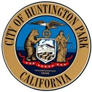

CITY OF

HUNTINGTON PARK

City Council

Regular Meeting

Tuesday, August 6, 2024

CANCELLED

Next Regular Meeting is scheduled for

Tuesday, August 20, 2024, at 6:00 p.m.

City Hall Council Chambers

6550 Miles Avenue, Huntington Park, CA 90255

I Eduardo Sarmiento, hereby certify under penalty of perjury under the laws of the State of California that the foregoing agenda was posted at City of Huntington Park City Hall and made available at www.hpca.gov on the 1st of August, 2024.

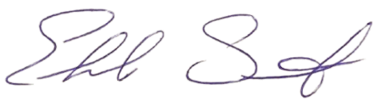

_________________________________
Eduardo Sarmiento, City Clerk

