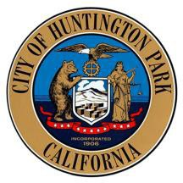
Traffic Authority Meeting

NOTICE OF CANCELLED MEETING

CITY OF HUNTINGTON PARK TRAFFIC AUTHORITY

NOTICE IS HEREBY GIVEN that the September 7, 2023, regular meeting of the City of Huntington Park Traffic Authority is CANCELLED.

NOTE: The next regular meeting is scheduled for Thursday, October 5, 2023, at 10:00 a.m. Huntington Park City Hall, 2nd Floor in the Council Chambers, 6550 Miles Avenue, Huntington Park, CA.
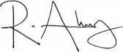

Raul Alvarez
Assistant City Manager

6550 Miles Avenue  Huntington Park, CA 90255  www.hpca.gov  (323) 582-6161

