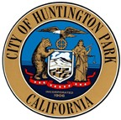

CITY OF
HUNTINGTON PARK

Health and Education Commission
Regular Meeting Agenda
Tuesday, December 28, 2021

CANCELLED

Next Meeting is scheduled for
Tuesday, January 25, 2021
Salt Lake Park, Lounge
3401 E Florence Avenue Huntington Park, CA 90255

I, Cynthia Norzagaray, hereby certify under penalty of perjury under the laws of the State of California that the foregoing agenda was posted at 3401 E. Florence Ave. and at 6550 Miles Avenue, Huntington Park, CA 90255 and made available at www.hpca.gov on December 22, 2021.

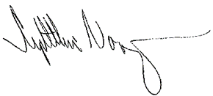
_____________________________________
Cynthia Norzagaray, Director of Parks and Recreation

