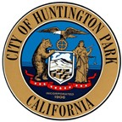

CITY OF HUNTINGTON PARK
Youth Commission
Regular Meeting
December 23, 2020

CANCELLED
Next Regular Meeting is scheduled for
Monday, January 27, 2021 at 4:00 p.m.
Salt Lake Park Lounge
3401 E. Florence Avenue, Huntington Park, CA 90255

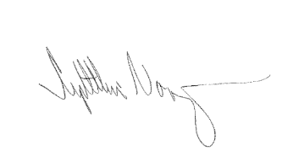
I, Cynthia Norzagaray, hereby certify under penalty of perjury under the laws of the State of California that the foregoing agenda was posted at City of Huntington Park City Hall, Salt Lake Park, and made available at www.hpca.gov on the 8th of December 2020

________________________________________
Cynthia Norzagaray, Director of Parks and Recreation

