CITY OF
HUNTINGTON PARK

Youth Commission
Regular Meeting Agenda
Wednesday, October 28, 2020
4:00 p.m.
Salt Lake Park, Lounge
3401 E. Florence, Huntington Park, CA 90255
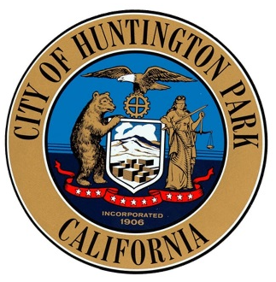

All agenda items and reports are available for review in the Parks and Recreation Office and www.hpca.gov. Any writings or documents provided to a majority of the Parks & Recreation commission regarding any item on this agenda (other than writings legally exempt from public disclosure) will be made available for public in the Office of the Parks and Recreation Department located at 3401 E. Florence Avenue, Huntington Park, California 90255 during regular business hours, 8:00 a.m. to 7:00 p.m., Monday – Thursday, and at the City Hall Council Chambers during the meeting. Any person who requires a disability-related modification or accommodation, including auxiliary aids or services, in order to participate in the public meeting may request such modification, accommodation, aid or service by contacting the Parks and Recreation Office either in person at 3401 E. Florence Avenue, Huntington Park, California or by telephone at (323) 584-6218. Notification in advance of the meeting will enable the City to make reasonable arrangements to ensure accessibility to this meeting.

PLEASE SILENCE ALL CELL PHONES AND OTHER ELECTRONIC EQUIPMENT WHILE THE COMMISSION IS IN SESSION. Thank you.

Assembly Bill No. 2674 amended several provisions of the Ralph M. Brown Act (Section 54590 tense. of the Government code) effective January 1, 1987. The bill prohibits the Youth Commission from taking action on any item which did not appear on the agenda, which was posted 72 hours prior to the Youth Commission meeting. If the Commission action is necessary on subject matter which the public presents the matter should be presented in writing to the Director of Parks & Recreation for placement on the agenda by Wednesday noon, prior to the next Youth Commission meeting.

Additions/Deletions to Agenda

Items of business may be added to the agenda upon a motion adopted by a minimum two-thirds vote finding that there is a need to take immediate action and that the need for action came to the attention of staff subsequent to the agenda being posted. Items may be deleted from the agenda upon the request of staff or the Commission.

CALL TO ORDER

ROLL CALL
Chair Joel Palma
Vice Chair Joanna Ramos
Secretary Kelly Martinez
Commissioner Brandon Valdez
Commissioner
Commissioner

PLEDGE OF ALLEGIANCE

PUBLIC COMMENT
If you would like to comment on any listed Agenda Items or Non-Agenda Items, please email Rene Rubalcava at RRubalcava@hpca.gov or by telephone, by calling (323) 584-6218, up until one (1) hour, prior to the start of the meeting. Public Comments will then be read during public comment and made part of the record. The City of Huntington Park thanks you in advance for your cooperation. This is the only opportunity for public input except for scheduled public hearing items.

CONSENT CALENDAR

- Approve the regular meeting minutes from September 23, 2020 Youth Commission meeting.

PRESENTATIONS

- Chair Joel Palma will share overall thoughts on PPE Event

REGULAR AGENDA

- Discussion and/ or Action of participation of upcoming special events:
  - City Council Halloween 2020. Staff will be handing out candy to families and taking their pictures.
- Discussion and/ or Action of participation of Public Health Advocates Participation Opportunity.
- Discussion and/ or Action of participation on Positive messages for Virtual learning for Students:
  - Bio from Commissioners with positive message on Social media
  - Please follow example and provide picture.
DEPARTMENTAL REPORTS (Information Only)
- Halloween Event
- Halloween Decoration Contest for Residents

WRITTEN COMMUNICATIONS
- Halloween Decoration Contest for Residents

COMMISSION COMMUNICATIONS
Chair Joel Palma
Vice Chair Joanna Ramos
Secretary Kelly Martinez
Commissioner Brandon Valdez
Four Vacancies

ADJOURNMENT

The City of Huntington Park, Youth Commission will adjourn to the regular meeting. The next regular scheduled meeting will be November 25, 2020.

Note: Any person who has a question concerning any agenda item may contact the Parks and Recreation Director, Cynthia Norzagaray. All back-up material is available for review in the Parks & Recreation Administrative office during regular working hours and online on the City’s official website.

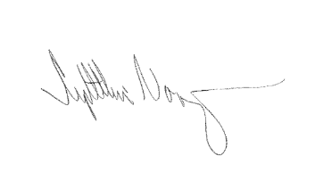
I, Cynthia Norzagaray, hereby certify under penalty of perjury under the laws of the State of California that the foregoing agenda was posted at 3401 E. Florence Ave. and at 6550 Miles Avenue, Huntington Park, CA 90255 and made available at www.hpca.gov on October 23, 2020.

_____________________________________
Cynthia Norzagaray, Director of Parks and Recreation

