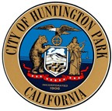

CITY OF HUNTINGTON PARK
Youth Commission
Regular Meeting
Monday, April 22, 2020

CANCELLED
Next Regular Meeting is scheduled for
Monday, May 27, 2020 at 4:00 p.m.
Salt Lake Park Lounge
3401 E. Florence Avenue, Huntington Park, CA 90255

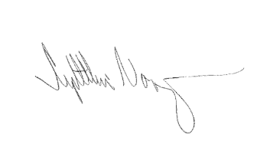
I, Cynthia Norzagaray, hereby certify under penalty of perjury under the laws of the State of California that the foregoing agenda was posted at City of Huntington Park City Hall, Salt Lake Park, and made available at www.hpca.gov on the 13th of April, 2020.

________________________________________
Cynthia Norzagaray, Director of Parks and Recreation

