CITY OF
HUNTINGTON PARK

Youth Commission
Regular Meeting Agenda
Wednesday, February 26, 2020

4:00 p.m.
Salt Lake Park, Lounge
3401 E. Florence, Huntington Park, CA 90255

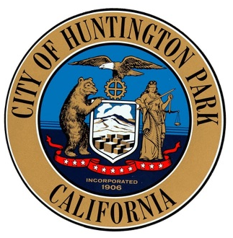

All agenda items and reports are available for review in the Parks and Recreation Office and www.hpca.gov. Any writings or documents provided to a majority of the Parks & Recreation commission regarding any item on this agenda (other than writings legally exempt from public disclosure) will be made available for public in the Office of the Parks and Recreation Department located at 3401 E. Florence Avenue, Huntington Park, California 90255 during regular business hours, 8:00 a.m. to 7:00 p.m., Monday – Thursday, and at the City Hall Council Chambers during the meeting. Any person who requires a disability-related modification or accommodation, including auxiliary aids or services, in order to participate in the public meeting may request such modification, accommodation, aid or service by contacting the Parks and Recreation Office either in person at 3401 E. Florence Avenue, Huntington Park, California or by telephone at (323) 584-6218. Notification in advance of the meeting will enable the City to make reasonable arrangements to ensure accessibility to this meeting.

PLEASE SILENCE ALL CELL PHONES AND OTHER ELECTRONIC EQUIPMENT WHILE THE COMMISSION IS IN SESSION. Thank you.

Assembly Bill No. 2674 amended several provisions of the Ralph M. Brown Act (Section 54590 tense. of the Government code) effective January 1, 1987. The bill prohibits the Youth Commission from taking action on any item which did not appear on the agenda, which was posted 72 hours prior to the Youth Commission meeting. If the Commission action is necessary on subject matter which the public presents the matter should be presented in writing to the Director of Parks & Recreation for placement on the agenda by Wednesday noon, prior to the next Youth Commission meeting.

Additions/Deletions to Agenda

Items of business may be added to the agenda upon a motion adopted by a minimum two-thirds vote finding that there is a need to take immediate action and that the need for action came to the attention of staff subsequent to the agenda being posted. Items may be deleted from the agenda upon the request of staff or the Commission.

CALL TO ORDER

ROLL CALL
Chair Kimberly Guzman
Vice Chair Joel Palma
Secretary Vacant
Commissioner Brandon Valdez
Commissioner Kelly Martinez
Commissioner Joanna Ramos

PLEDGE OF ALLEGIANCE

PUBLIC COMMENT

If you wish to address the Commission, please complete the speaker card that is provided at the entrance to the room and give to staff prior to the start of Public Comment. For both open session each speaker will be limited to three minutes per Huntington Park Municipal Code Section 2-1.207. Time limits may not be shared with other speakers and may not accumulate from one period of public comment to another or from one meeting to another. This is the only opportunity for public input except for scheduled public hearing items.

CONSENT CALENDAR

- Approve the regular meeting minutes from September 25, 2019 Youth Commission meeting.

PRESENTATIONS

REGULAR AGENDA

- Discussion and/or Action of participation on “What does it mean to be a Youth Commissioner, and what can you do to be a positive role model in the community? What do you want to accomplish in this committee?”
- Discussion and/ or Action of participation of upcoming special events:
  - Senior Food Pantry. Thursday, March 19, 2020 at 1pm at Senior Center.
  - Egg Hunt & Breakfast with Bunny. April 4, 2020 at 8am. Salt Lake Park.
  - 5K & Health Expo. May 2, 2020.

- Discussion and/ or Action of participation of Youth Commission Vacancies.

DEPARTMENTAL REPORTS (Information Only)

WRITTEN COMMUNICATIONS

COMMISSION COMMUNICATIONS
Chair Kimberly Guzman
Vice Chair Joel Palma
Secretary Vacant
Commissioner Brandon Valdez
Commissioner Kelly Martinez
Joanna Ramos
Four Vacancies

ADJOURNMENT

The City of Huntington Park, Youth Commission will adjourn to the regular meeting. The next regular scheduled meeting will be March 25, 2020.

Note: Any person who has a question concerning any agenda item may contact the Parks and Recreation Director, Cynthia Norzagaray. All back-up material is available for review in the Parks & Recreation Administrative office during regular working hours and online on the City’s official website.

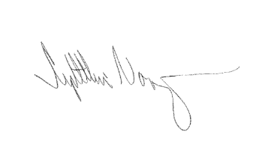
I, Cynthia Norzagaray, hereby certify under penalty of perjury under the laws of the State of California that the foregoing agenda was posted at 3401 E. Florence Ave. and at 6550 Miles Avenue, Huntington Park, CA 90255 and made available at www.hpca.gov on February 25, 2020.

_____________________________________
Cynthia Norzagaray, Director of Parks and Recreation

